**Smart Steel & Bricks**



*Developed By*

**Abdul Rafay**

**3992-FBAS/BSCS/F18**

**Hasan Riaz**

**4057-FBAS/BSCS/F18**

BS Computer Science

*Supervisor*

Department of Computer Science & Software Engineering

Faculty of Computing

International Islamic University, Islamabad

(2023)

*Final Approval*

**FINAL APPROVAL**

Dated:_____________

It is certified that I have read the project report titled **Smart Steel & Bricks** submitted by **Abdul Rafay 3992-FBAS/BSCS/F18**

**Hassan Riaz 4057-FBAS/BSCS/F18.**

It ismy judgement that this project is of enough standards to deserve its approval by the International Islamic University, Islamabad for Bachelor Degree in Computer Science

**External Examiner:**



**Mr. XYZ:**

Lecturer

Department of Computer Science & Software Engineering

International Islamic University, Islamabad.

**Internal Examiner:**

**Mr. XYZ**

Lecturer

Department of Computer Science & Software Engineering

International Islamic University, Islamabad.

**Supervisor:**

**Mr. XYZ**

Lecturer

Department of Computer Science & Software Engineering

International Islamic University, Islamabad.

Smart Steel & Bricks **i**

*Dissertation*

**DISSERTATION**

A dissertation submitted to the Department of Computer Science & Software Engineering, International Islamic University Islamabad. As a partial fulfillment of desires, for the award of the degree BS in Computer Science.

Smart Steel & Bricks **ii**

*Dedication*

**DEDICATION**

I bestow this project to Almighty Allah, who gave us the ability and strength to complete this task as our final year project. This project is also dedicated to our beloved parents, whose affection, love, support and prayers made it possible to succeed, along with our hardworking, inspiring and respected teachers, supervisor and friends who supported and helped us through thick and thin.

Smart Steel & Bricks **iii**

*Declaration*

**DECLARATION**

I hereby declare that this Software, neither as a whole nor as a part thereof has been copied out from any source. It is further declared that I have developed this Software entirely on the basis of my personal efforts made under the sincere guidance of my teachers and supervisor. No portion of the work presented in this report has been submitted in support of any application for any other degree or qualification of this or any other university or institute of learning.

**Abdul Rafay**

3992-FBAS/BSCS/F18A

**Hassan Riaz**

4057-FBAS/BSCS/F18A

Smart Steel & Bricks **iv**

*Acknowledgement*

**ACKNOWLEDGEMENT**

All praises be to Allah Almighty, who has blessed me with the ability and strength to successfully complete the task of completion this final year project. I also thank Computer Science Department IIUI for giving me the opportunity and necessary facilities that enabled me to do my project at this level. At the end, I would like to pay gratitude to my parents for their moral support and motivation.

Smart Steel & Bricks **v**

*Project in Brief*

**PROJECT IN BRIEF**

|  |  |
| --- | --- |
| **Project Title:** | Smart Steel & Bricks |
|  |  |
| **Undertaken By:** | Abdul Rafay and Hassan Riaz |
|  |  |
| **Supervisor:** | MR. XYZ |
|  |  |
| **Starting Date:** | 22-10-2022 |
|  |  |
| **Completion Date:** | 19-01-2023 |
|  |  |
| **Software, Languages, and** | MERN STACK ( MongoDB, Express, React.js, Node.js) |
| **Technologies Used:** | Microsoft Visual Studio Code, HTML5, CSS3, JavaScript |
|  |  |
| **System Information:** | Core i9, RAM 18 GB |
|  |  |

Smart Steel & Bricks **vi**

*Abstract*

**ABSTRACT**

Smart Steel & Bricks is primarily designed to make people's lives easier and more comfortable by making it easier for them to achieve their building goals. Most of the time, people have to go to Building Materials or other home supplies because they have to, and women have to deal with this headache. They sometimes don't feel safe going out to get Building Material. Customers will also be able to easily check the availability of every Material and the price of each Material online, making it simple for them to check everything on our platform. The places where internet service is available are critical to our system. This system also helps people who are afraid to calculate home costs, especially engineers. We offer a Material Estimation Calculator, which is essential in today's world..

Smart Steel & Bricks **vii**

*Table of Contents*

**Table of Contents**

**List of Tables****xi**

**List of Figures****xii**

**Chapter 1 Introduction****1**

1. Introduction………………………………………………………………....2

1.1 Purpose 2

1.2 Scope 3

1.3 Background Information 3

1.4 Problem Statement 4

1.5 Objective 4

1.6 Modules 5

1.7 Constraints 5

1.7.1 Internet 5

1.7.2 Stripe Master Card 5

**Chapter 2** **Existing Systems****6**

2. Existing System 7

2.1 Existing System Problems 8

2.1.1 Estimator Calculator 8

2.1.2 Material Calculator 8

2.1.3 Haute Vault 8

2.1.4 Red Carpet Rocks 8

2.2 Improvements Over Other Systems 9

2.2.1 Online Payments 9

2.2.2 Convenience in Queries 9

2.2.3 Central Dispatch 9

2.2.4 Data Integrity and Security 9

2.3 Conclusion 10

**Chapter 3** **System Analysis****11**

3. System Analysis 12

3.1 Functional Analysis 12

3.1.1 Admin 13

3.1.2  Smart Steel & Bricks Staff 13

3.1.3 User 13

Smart Steel & Bricks **viii**

*Table of Contents*

3.2 UML Diagrams 14

3.2.1 Use Case Diagram 14

3.2.2 Descriptive Use Cases 15

3.3 System Sequence Diagrams 28

3.3.1 Admin System Sequence Diagram 28

3.3.2 User System Sequence Diagram 29

3.3.3 Whole System Sequence Diagram 30

**Chapter 4** **System Design****31**

4. System Design 32

4.1 Architectural Diagram 32

4.2 Data Flow Diagram 33

4.3 Class Diagram 35

4.4 ERD/Database Schema 36

**Chapter 5** **Implementation****37**

5. Implementation 38

5.1 Frontend 38

5.2 Backend 39

5.3 Database 39

5.4 Development Tools 41

5.5 System UI 42

5.5.1 Login / Register 42

5.5.2 Profile Section 42

5.5.3 Home Page 43

5.5.4 Admin Dashboard 44

5.5.5 Create New Product 45

5.5.6 Orders Page 45

5.5.7 Product Details 46

5.5.8 Cart 46

5.5.9 Shipping Details 47

5.5.10 Card Details 47

5.5.11 Order Details 48

5.5.12 About Page 48

5.5.13 Collections Page 49

5.5.14 Estimation Calculator 49

Smart Steel & Bricks **ix**

*Table of Contents*

**Chapter 6** **System Testing****51**

6. System Testing 52

6.1 Test Cases 52

6.2 Performance Evaluation 56

6.3 Testing Summary 56

**Chapter 7** **Conclusion****57**

7. Conclusion 57

7.1 Achievements and Improvements 57

7.2 Future Enhancements 58

**References****59**

Documentation 60

General Queries 60

Smart Steel & Bricks **x**

*List of Tables*

**List of Tables**

**Table 2-1** Existing Systems Comparison**7**

**Table 3-1** Use Case Register**15**

**Table 3-2** Use Case Login**16**

**Table 3-3** Use Case Switch Roles**17**

**Table 3-4** Use Case Dashboard**18**

**Table 3-5** Use Case Events**19**

**Table 3-6** Use Case Estimation Calculator**20**

**Table 3-7** Use Case Chatbot**21**

**Table 3-8** Use Case Add to Cart**22**

**Table 3-9** Use Case Customization**23**

**Table 3-10** Use Case Make Payment**24**

**Table 3-11** Use Case Manage Product**25**

**Table 3-12** Use Case Ratings / Feedback**26**

**Table 3-13** Use Case Confirm Order**27**

**Table 5-1** Development Tools**41**

**Table 6-1** Test Cases # 1 Register & Login**53**

**Table 6-2** Test Cases # 2 Manage Profiles **53**

**Table 6-3** Test Cases # 3 Clicks,Impression & Veiws**53**

**Table 6-4** Test Cases # 4 Orders Records**53**

**Table 6-5** Test Cases # 5 Query Products**55**

**Table 6-6** Test Cases # 6 Payment Gateway**55**

Smart Steel & Bricks **xi**

*List of Figures*

**List of Figures**

**Figure 3-1** Smart Steel & Bricks Use Case Diagram**14**

**Figure 3-2** Admin View System Sequence Diagram**28**

**Figure 3-3** Customer View System Sequence Diagram**29**

**Figure 3-4** Whole System Sequence Diagram**30**

**Figure 4-1** Architecture Diagram**32**

**Figure 4-2** Data Flow Diagram**33**

**Figure 4-3** Class Diagram**35**

**Figure 4-4** ERD/Database Schema **35**

**Figure 5-1** React Architecture Diagram**38**

**Figure 5-2** MongoDB Basic Architecture Diagram**40**

Smart Steel & Bricks **xii**

**CHAPTER 1**

**INTRODUCTION**

*Chapter 1* *Introduction*

1. Introduction

Electronic trade, or online business, is the buying and selling of building materials and products over electronic frameworks like the Internet and other PC networks. Electronic monetary exchanges, supply chain management, Internet advertising, online transaction handling, Electronic Data Interchange (EDI), stock administration frameworks, and robotized information assortment frameworks are examples of innovations utilized in electronic business.

The e-business deals component is occasionally hinted at here. It also includes information interchange to simplify financial and payment aspects of business transactions. Even now, despite the so-called "website/Internet transition," electronic trade (online company) is a remarkably fresh, dynamic, and continually evolving area of organisational the board and data innovation. E-business has received a lot of attention and discussion, and it continues to do so. There are numerous library indexes and retires in the books and articles that deal with the subject.

However, there is still a sense of dread and ignorance about the topic, which has grown as a result of the varied contexts in which electronic building material trading is employed as well as the numerous current terms and abbreviations associated with it. Internet and e-business have quickly evolved into essential components of corporate operations and a potent engine for economic growth in the developing global economy. The use of information and communication technology (ICT) in the workplace has altered relationships both within businesses and between organisations and people.

1.1 Purpose

Essential subject behind this endeavor is to make buying building material easier without with lots but idle time. Furthermore, one of the main things, we need to bring a web-based framework which will be very straightforwardness for the purchaser to check each building material with depiction for each capacity. For instance, on the off chance that an individual has a specific financial plan.

Smart Steel & Bricks **2**

*Chapter 1* *Introduction*

Presently he/she don't have to visit each and every building material store and requesting the cost and accessibility of building material. He/she will simply open our online stage and search every one of building material. In the event that the building material isn't found, he can tweak as needs be as well as essentially attempt those items virtually. Then it will be simple for the purchaser to get a gauge of the building material he needs to purchase.

1.2 Scope

Fashion for everyone has always been a strong conviction. However, when distributing construction supplies to everyone. We fail to remember that there are people in the world who lack even the building blocks for basic comforts.

Every customer should need a product for their exceptional days. In Pakistan, there are equivalent stages. Similar to frameworks, which are widely available online but have very limited policies and failed to gain traction in the market.

Smart Steel & Bricks has a very important and significant extension in providing people with ease. Compared to Smart Steel & Bricks, global item platforms have exceptionally strict goods exchange policies.

1.3 Background Information

The traditional way of submitting forms and asking queries was carried out using manual system or noticeboards were used to make announcements. For university, it was almost impossible to maintain the records of all the forms and the queries of students are left unanswered because of overcrowding at program office. Providing feedback on the concerns of each student was a time-consuming and labor-intensive process

Moreover, filtering out from thousands of forms is unrealistic and unmanageable. Thus, to overcome all these issues, a well-maintained database with a user-friendly interface was required, and thus this web application will simplify all the needs of the university, staff and student

Smart Steel & Bricks **3**

*Chapter 1* *Introduction*

1.4 Problem Statement

In a manual system, the customer may have to deal with a variety of challenges, such as haggling, a lack of information about the item, and having to visit several stores to buy the same item, which is quite inconvenient. Value disparity is another really worrying issue; different shops charge different prices for the same item. Dealing is also a very embarrassing second for the buyer. Time is important to everyone. If there is a service that allows customers to acquire complete information on every store nearby, they should use it.

Normal issues confronted are as per the following.

* Tedious.
* Customer Dissatisfaction.
* Contemptibility of Sellers.
* Accessibility
* Absurd Prices.

Furthermore, keeping the pandemic in mind, it is even more reason the get rid of manual systems to prevent overcrowding and potential spread of covid-19.

1.5 Objective

The main goal of this project is to reduce the amount of time spent searching for Steel & Bricks. One of the most important things is to develop a web-based framework that will make it simple for buyers to view each item's representation for each construction material's capacity. For instance, in the unlikely event that someone has a detailed financial plan. He or she no longer needs to visit every store to inquire about the price and availability of an item. He or she will just open our online platform and go over all of the right items. If the ideal item isn't found, he can adjust as necessary and virtually try other items if necessary. Afterward, it will be easy.

Smart Steel & Bricks **4**

*Chapter 1* *Introduction*

1.6 Modules

* Sign up, sign in, logout, forgot password, reset password.
* Facilitating customers without visiting every single Building Material Thiea.
* Process orders online.
* Engineers / Users can also calculate Home Material Estimation.
* Estimation Calculator.
* Payment Methods i.e., Stripe.
* Promotional offers by true Notifications.
* Customers can inquire about Steel & Bricks i.e., Chatbot
* Customers will be able to give their Feedback.
* Customers will get the Invoice for their successful transaction.
* Extensive sales statistics i.e., Admin Dashboard.
* Email notifications / on each and every stage of order and forget password

1.7 Constraints

For the web app to work properly certain constraints must be taken care of. Even if the web application is installed as progressive web app the constraints of this project listed below must be tended to.

**1.7.1** **Internet**

All features are internet dependent; therefore, the web app will not work without an Internet connection and will simply not be accessible.

**1.7.2** **Stripe Master Card**

A stripe MasterCard will be required in order to proceed to payments section.

Smart Steel & Bricks **5**

**Chapter 2**

**Existing Systems**

*Chapter 2* *Existing System*

1. Existing System

This chapter will address the theoretical underpinnings that will serve as the study's foundation and framework. The development of web applications and research into previously created building materials served as the foundation for this framework. Any project that attempts to advance the development of Smart Steel & Bricks will directly be impacted by both of these domains. It will be possible to fulfil the goal of describing how this system differs from "conventional" system development by offering a theoretical framework for web application development handling. The goal is to gather and assess a set of functionality that these projects accomplished, along with the outcomes from the user trials of the individual systems, by analysing research on already built rental systems.

**Table 0-1** Existing Systems Comparison

|  |  |  |  |  |
| --- | --- | --- | --- | --- |
| **Sr** | **Characteristics** | **Manual** | **Haute** | **Smart Steel & Bricks** |
| **No.** |  |  | **Vault** |  |
| 1 | Security |  |  | ✓ |
|  |  |  |  |  |
| 2 | Prone to Error | ✓ | ✓ |  |
|  |  |  |  |  |
| 3 | Proper Validation |  | ✓ | ✓ |
|  |  |  |  |  |
| 4 | Feedback Panel |  |  | ✓ |
|  |  |  |  |  |
| 5 | Admin Panel |  |  | ✓ |
|  |  |  |  |  |
| 6 | Convenience |  | ✓ | ✓ |
|  |  |  |  |  |
| 7 | Cloud Database |  | ✓ | ✓ |
|  |  |  |  |  |
| 8 | Notifications |  |  | ✓ |
|  |  |  |  |  |
| 9 | Material Estimator |  |  | ✓ |
|  |  |  |  |  |

Smart Steel & Bricks **7**

*Chapter 2* *Existing System*

2.1 Existing System Problems

It's time to adapt to the modern world. The existing method is manual and involves a lot of human labour to complete tasks, which results in significant time and financial waste. It can also quickly become stressful for both buyers and employees, who manage hundreds of collections each day for various events and estimates. The following are some of the features of current systems that are occasionally employed.

**2.1.1** **Estimator Calculator**

Although Smart Steel & Bricks, an online platform similar to it, has a very limited scope (only Rajasthan, India), where you may acquire the cost of a house, many people used this website to look at the price and design of the accessories as it were.

**2.1.2** **Material calculator**

Another online platform where you can find the prices of Accessories and directly make purchases is Smart Steel & Bricks. However, leasing is quite expensive, and the nature of the Products doesn't justify the cost..

**2.1.3** **Haute Vault**

Haute Vault is another web-based stage where you can get the costs of Materials and you can straightforwardly purchase from it. Yet, the expense of products is exceptionally high and the nature of the Material is not up-to the cost.

**2.1.4** **Red Carpet Rocks**

Announcements are sent through WhatsApp or notice boards which can lead to discrepancies and confusion in authenticity of the message.

Smart Steel & Bricks **8**

*Chapter 2* *Existing System*

2.2 Improvements Over Other Systems

Requirements gathering is a common early step in software development projects, and there are few differences between "conventional" and web application development in terms of how this is done. When gathering and analysing requirements for web applications, a possibly bigger, more varied, and loosely defined target group of users must be taken into consideration. However, requirement gathering may be done in both circumstances using the same methodologies.

Based on the knowledge we have gained from working with existing systems, the application we want to create will have the following advantages.

**2.2.1** **Online Payments**

There will be no more uncomfortable visits and hassles with filling out paperwork, photocopying everything, and physically submitting it, reducing wasteful usage of paper, time, and labor.

**2.2.2** **Convenience in Queries**

There won't be any more unanswered questions. Online inquiries can be made, and staff members will respond in a short amount of time.

**2.2.3** **Central Dispatch**

Buyers may stay informed on the most recent building materials, deadline reminders, changes in policies, etc. without becoming lost in a sea of perplexing statements thanks to an official line of dispatch and one central spot for all notifications.

**2.2.4** **Data Integrity and Security**

A secure database that is kept up to date and well-maintained for all user interactions, with an automated backup in case the database is lost.

Smart Steel & Bricks **9**

*Chapter 2* *Existing System*

2.3 Conclusion

There are several websites that offer the ability to use an estimator and shop for building materials online. However, due to trust issues, buying anything from a thief carries a significant risk. They occasionally received items that were off-base and weren't prepared to hand them back to the Building Material Thief. These associated sites just allow users to obtain an idea of the cost; occasionally, users make up costs that are higher than the actual ones. We shall provide a platform where everything will be very much made due in any circumstance. giving the two buyers and the administrator various components. As a result, there are some existing frameworks, such as Askari Cement, under this section. The lack of a Customization utility in the two locations is the main problem. Therefore, customers are unable to exchange for their preferred Building Materials.

Smart Steel & Bricks **10**

**Chapter 3**

**System Analysis**

*Chapter 3* *System Analysis*

1. System Analysis

The first step of development is analysis. They are the capabilities that are desired to be conveyed by the system (framework). This is the procedure of demonstrating finding and refinement. It might be capabilities required by the user or limitations which of the tech stack used. In the following, requirements are divided into several sub-requirements. Then it is analyzed so that we have the complete sketch of the desired system we are trying to implement.

This also involves different ways through which the researcher can get the information regarding the application to be designed and the system that is currently being used and at the same time, it enables the development team to communicate with stakeholders in a language they understand (like charts, models, flow-charts,) instead of pages of text. Data collection methods to be used include requirement analysis, observation, documentation review, constraints and more. The system's services, constraints and goals are, established by consultation with system users. They are then defined in detail and serve as a system specification.

Additionally, we monitor the systems to debug, troubleshoot, or implement them. It is used in the early stages of a project when computer-based systems need a precise analysis based on their structure and design specifications. The requirements are divided throughout the systems design process, which also creates a general system architecture. The underlying software system abstractions and their interactions must be recognized and described as part of the programmed design process. The methods utilized to analyze this online application of current systems in comparison to Smart Steel & Bricks are as follows.

3.1 Functional Analysis

This collaboration at a high level across system concepts describes the system's overall structure. The following structure is used to study how the system interacts with users and the characteristics that actors can use:

|  |  |
| --- | --- |
| Smart Steel & Bricks | **12** |

*Chapter 3* *System Analysis*

**3.1.1** **Admin**

Admin has the highest level of control in Smart Steel & Bricks. The actions they can perform are structured as follows:

* Perform CRUD operations on all the database models
* Authorize and give permissions to different Users to perform different tasks
* Oversee all operations in the web application

**3.1.2** **Smart Steel & Bricks Staff**

The Admin can approve and add the Smart Steel & Bricks staff as moderators. The actions that can be performed by them are as follows:

* Make announcements/discounts
* Send SMS messages to all or specified users
* Respond to queries/suggestions
* Change user status
* Building Cost Estimator Calculator

**3.1.3** **User**

After registering and signing into the app, the features allocated to them are as follows:

* Search for Specific Smart Steel & Bricks
* Calculate Building Material costs
* Post ratings
* Give Feedback on different products
* Make appropriate changes to profile through dashboard
* View Smart Steel & Bricks, Cart etc.

Smart Steel & Bricks **13**

*Chapter 3* *System Analysis*

3.2 UML Diagrams

Unified Modeling Language, is a way to visually represent the architecture, design, and implementation of complex software systems. When you’re writing code, there are thousands of lines in an application, and it’s difficult to keep track of the relationships and hierarchies within a software system. UML diagrams divide that software system into components and subcomponents. They are structured as follows:

3.2.1 Use Case Diagram

**Figure 0.1** Use Case Diagram of Smart Steel and Bricks

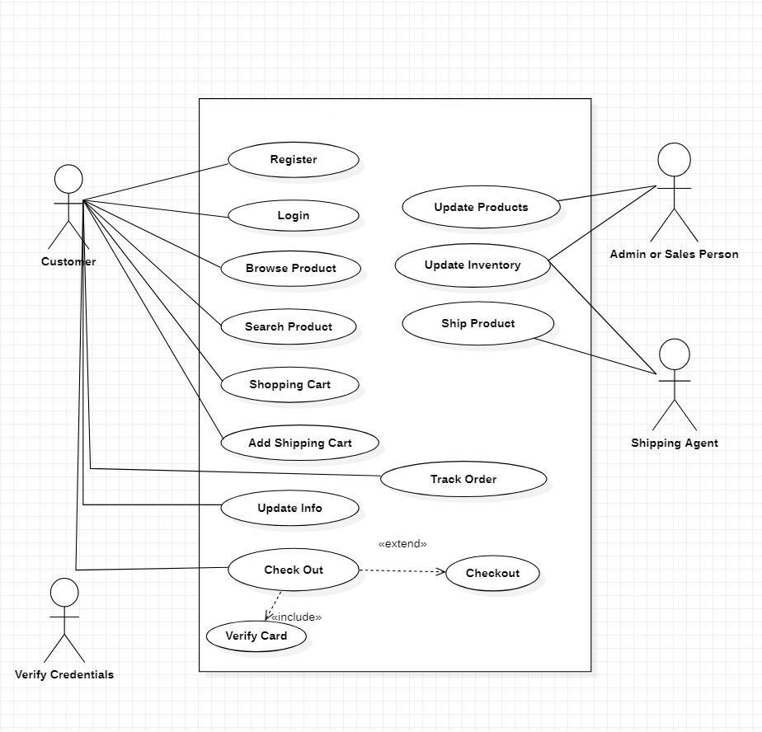

Smart Steel & Bricks **14**

*Chapter 3* *System Analysis*

**3.2.2** **Descriptive Use Cases**

Use cases are a definition of a specific goal that the system must achieve in software and systems engineering. By specifying the numerous external actors (or entities) that are present outside of the system and the precise interactions they have with the system in the achievement of the business objective, a use-case will define this process.

Following are the main use cases of Smart Steel & Bricks:

**Use case Register:** which tells how a user is registered to the web application.

|  |  |  |
| --- | --- | --- |
|  |  | **Table 0-1** Use Case Register |
|  |  | |
| **Use case ID:** | UC-1 | |
|  |  | |
| **Primary Actor(s):** | Customer / Admin | |
|  |  | |
| **Scope** | Smart Steel & Bricks | |
|  |  | |
| **Goal** | Enable user to use the features provided by the platform | |
|  |  | |
| **Pre-Conditions** | Should have a stable connection. | |
|  |  | |
| **Post-Conditions** | Account created successfully and User is registered. | |
|  |  |  |
| **Main success** | 1. | User provided the required information and system creates |
| **scenario** |  | an account. |
|  | 2. | System verified the email, created the account and User is |
|  |  | registered successfully. |
|  |  |  |
| **Alternative Flow** | 1. | Invalid email |
|  | 2. | Email already exists |
|  |  |  |

Smart Steel & Bricks **15**

*Chapter 3* *System Analysis*

**Use case login details**; which tells how a user is logged in to the web application.

|  |  |
| --- | --- |
|  | **Table 0-2** Use Case Login |
|  |  |
| **Use case ID:** | UC-2 |
|  |  |
| **Primary** | Customer / Admin |
| **Actor(s):** |  |
|  |  |
| **Scope** | Smart Steel & Bricks |
|  |  |
| **Goal** | Enable user to use the features provided by the platform like |
|  | feedback, browse events, query etc. |
|  |  |
| **Pre-Conditions** | Should have a stable connection and valid credentials |
|  |  |
| **Post-Conditions** | User logged in successfully and is able to use all the features |
|  |  |
| **Main success** | 1. User provided the required information |
| **scenario** | 2. System verifies the credentials and redirects the user to the |
|  | homepage |
|  |  |
| **Alternative** | 1. Incorrect Username or Password |
| **Flow** | 2. Account does not exist |
|  |  |

Smart Steel & Bricks **16**

*Chapter 3* *System Analysis*

**Use case Switch Roles**; which tells how an admin authorizes a user for admin role to the web application.

|  |  |
| --- | --- |
|  | **Table 0-3** Use Case Switch Roles |
|  |  |
| **Use case ID:** | UC-3 |
|  |  |
| **Primary** | Admin |
| **Actor(s):** |  |
|  |  |
| **Scope** | Smart Steel & Bricks |
|  |  |
| **Goal** | Add and authorize users to make changes to models stored in |
|  | the database |
|  |  |
| **Pre-Conditions** | Should have a stable connection and super admin credentials |
|  |  |
| **Post-Conditions** | User authorized successfully and is able to make changes to the |
|  | models they are given permission for. |
|  |  |
| **Main success** | 1. User provided the required information |
| **scenario** | 2. System verified the credentials and redirects the user to the |
|  | Admin homepage |
|  | 3. User can provide different permissions and authorization to |
|  | other members successfully |
|  |  |
| **Alternative Flow** | 1. Incorrect Username or Password |
|  | 2. Account is not a super admin and cannot authorize |
|  | permissions |
|  |  |

Smart Steel & Bricks **17**

*Chapter 3* *System Analysis*

**Use case dashboard details**; which tells how an admin staff can manage users, products, and all the other models in the web application. Admin can also enable and disable accounts.

Admins and users can also manage their respective dashboards.

|  |  |  |
| --- | --- | --- |
|  |  | **Table 0-4** Use Case Dashboard |
|  |  | |
| **Use case ID:** | UC-4 | |
|  |  | |
| **Primary Actor(s):** | Admin / Customer | |
|  |  | |
| **Scope** | Smart Steel & Bricks | |
|  |  | |
| **Goal** | Manage data | |
|  |  | |
| **Pre-Conditions** | Should be authorized and logged in with proper credentials | |
|  |  | |
| **Post-Conditions** | User authorized successfully and is able to make changes to | |
|  | the data they are authorized to change/manage. | |
|  |  |  |
| **Main success** | 1. | User provided the required information |
| **scenario** | 2. | System verified the credentials and redirects the user to the |
|  |  | relevant homepage |
|  | 3. | User can change/manage data successfully |
|  |  | |
| **Alternative Flow** | Incorrect Username or Password | |
|  |  |  |

Smart Steel & Bricks **18**

*Chapter 3* *System Analysis*

**Use case Events**; which tells how a user / member can Browse to events in the web application.

|  |  |
| --- | --- |
|  | **Table 0-5** Use Case Events |
|  |  |
| **Use case ID:** | UC-5 |
|  |  |
| **Primary Actor(s):** | Customers |
|  |  |
| **Scope** | Smart Steel & Bricks |
|  |  |
| **Goal** | To browse for specific Events |
|  |  |
| **Pre-Conditions** | Should be authorized and logged in with proper user |
|  | credentials |
|  |  |
| **Post-Conditions** | User authorized successfully and is able to specify events from |
|  | the list stored in the database |
|  |  |
| **Main success** | 1. User provided the required information |
| **scenario** | 2. System verified the credentials and redirects the user to the |
|  | Admin homepage |
|  | 3. User can offer various events successfully |
|  |  |
| **Alternative Flow** | 1. Incorrect Username or Password |
|  | 2. Account is not authorized |
|  |  |

Smart Steel & Bricks **19**

*Chapter 3* *System Analysis*

This use case shows how a Vendor can bid on the product on the product in the web application.

|  |  |
| --- | --- |
|  | **Table 0-6** Use Case Cost Estimation |
|  |  |
| **Use case ID:** | UC-6 |
|  |  |
| **Primary Actor(s):** | User / Visitor |
|  |  |
| **Scope** | Smart Steel & Bricks |
|  |  |
| **Goal** | Calculate Cost of House |
|  |  |
| **Pre-Conditions** | Not specified |
|  |  |
|  |  |
| **Post-Conditions** | Not specified |
|  |  |
|  |  |
|  |  |
| **Main success** | 1. User provides the required information |
| **scenario** |  |
|  |  |
|  |  |
|  |  |
| **Alternative Flow** | 1. Incorrect Username or Password |
|  | 2. Account is not authorized |
|  |  |

Smart Steel & Bricks **20**

*Chapter 3* *System Analysis*

This use case shows how a Program Office Staff member can add new batches in the web application.

|  |  |
| --- | --- |
|  | **Table 0-7** Use Case Chatbot |
|  |  |
| **Use case ID:** | UC-7 |
|  |  |
| **Primary Actor(s):** | Customers |
|  |  |
| **Scope** | Smart Steel & Bricks |
|  |  |
| **Goal** | Query processing |
|  |  |
| **Pre-Conditions** | Should be authorized and logged in with proper user |
|  | credentials |
|  |  |
| **Post-Conditions** | User authorized successfully and is able to get answers from |
|  | mobile |
|  |  |
| **Main success** | 1. User provided the required information |
| **scenario** | 2. System verified the credentials and redirects the user to the |
|  | Admin homepage |
|  | 3. User can process queries successfully |
|  |  |
| **Alternative Flow** | 1. Incorrect Username or Password |
|  | 2. Account is not authorized |
|  |  |

Smart Steel & Bricks **21**

*Chapter 3* *System Analysis*

This use case shows how a Customer can add the products to cart in the web application.

|  |  |
| --- | --- |
|  | **Table 0-8** Use Case Add to Cart |
|  |  |
| **Use case ID:** | UC-8 |
|  |  |
| **Primary Actor(s):** | Customers |
|  |  |
| **Scope** | Smart Steel & Bricks |
|  |  |
| **Goal** | Add Products to Cart |
|  |  |
| **Pre-Conditions** | Should be authorized and logged in with proper user |
|  | credentials |
|  |  |
| **Post-Conditions** | User authorized successfully and is able to add products to the |
|  | cart |
|  |  |
| **Main success** | 1. User provided the required information |
| **scenario** | 2. System verified the credentials and redirects the user to the |
|  | homepage |
|  | 3. User can add Products to the cart successfully |
|  |  |
| **Alternative Flow** | 1. Incorrect Username or Password |
|  | 2. Account is not authorized to add to cart |
|  |  |

Smart Steel & Bricks **22**

*Chapter 3* *System Analysis*

This use case shows how a user / member can customize their Products in the web application.

|  |  |  |
| --- | --- | --- |
|  |  | **Table 0-9** Use Case Customization |
|  |  | |
| **Use case ID:** | UC-9 | |
|  |  | |
| **Primary Actor(s):** | Customer | |
|  |  | |
| **Scope** | Smart Steel & Bricks | |
|  |  | |
| **Goal** | Customize Products | |
|  |  | |
| **Pre-Conditions** | 1. Should be authorized and logged in with proper user | |
|  |  | credentials |
|  |  | |
| **Post-Conditions** | User authorized successfully and is able to customize the | |
|  | dresses accordingly | |
|  |  |  |
| **Main success** | 1. | User provided the required information |
| **scenario** | 2. | System verified the credentials and redirects the user to |
|  |  | homepage |
|  | 3. | User can customize product successfully |
|  |  |  |
| **Alternative Flow** | 1. | Incorrect Username or Password |
|  |  |  |

Smart Steel & Bricks **23**

*Chapter 3* *System Analysis*

This use case shows how a user can make online payments using the web application.

|  |  |
| --- | --- |
|  | **Table 0-10** Use Case Make Payments |
|  |  |
| **Use case ID:** | UC-10 |
|  |  |
| **Primary Actor(s):** | Customers |
|  |  |
| **Scope** | Smart Steel & Bricks |
|  |  |
| **Goal** | To make Online Payments |
|  |  |
| **Pre-Conditions** | 1. Should be authorized and logged in with proper |
|  | credentials |
|  | 2. A Product must exist in cart which user can proceed |
|  | 3. User should not go over the specified Stock available |
|  |  |
| **Post-Conditions** | User authorized successfully and is able to make payments |
|  |  |
| **Main success** | 1. User provided the required information |
| **scenario** | 2. System verified the credentials and redirects the user to |
|  | the Payments page |
|  | 3. User selects the appropriate city and does not go over |
|  | Available stock. |
|  | 4. User is successfully able to pay after eligibility |
|  | verification from Stripe |
|  |  |
| **Alternative Flow A** | Incorrect Username or Password |
|  |  |
| **Alternative Flow B** | 1. User goes over the available stock |
|  | 2. Payment unsuccessful |
|  |  |
| **Alternative Flow C** | 1. User can try again |
|  | 2. User is rejected by Stripe due to eligibility |
|  | requirements |
|  |  |
| **Alternative Flow D** | User is unable to make payment due to less credit in |
|  | Account. |
|  |  |

Smart Steel & Bricks **24**

*Chapter 3* *System Analysis*

This use case shows how an admin can generate in using the web application

|  |  |  |
| --- | --- | --- |
|  |  | **Table 0-11** Use Case Manage Product |
|  |  | |
| **Use case ID:** | UC-11 | |
|  |  | |
| **Primary Actor(s):** | Admin | |
|  |  | |
| **Scope** | Smart Steel & Bricks | |
|  |  | |
| **Goal** | Generate returns and return the product condition | |
|  | accordingly | |
|  |  | |
| **Pre-Conditions** | 1. Should be authorized and logged in with proper | |
|  |  | credentials |
|  | 2. A Product must exist for which the vendor can bid | |
|  |  |  |
|  |  | |
|  |  | |
| **Post-Conditions** | Admin authorized successfully with login credentials | |
|  |  |  |
| **Main success** | 1. | Admin provided the required information |
| **scenario** | 2. | System verified the credentials and redirects the Admin |
|  |  | to the Admin Dashboard homepage |
|  | 3. | Admin checks |
|  | 4. | Admin successfully generated product |
|  |  | |
| **Alternative Flow A** | Incorrect Username or Password | |
|  |  | |
| **Alternative Flow B** | Admin is unable to generate product | |
|  |  |  |

Smart Steel & Bricks **25**

*Chapter 3* *System Analysis*

This use case shows how a Customer can post Ratings and comments in the web application.

|  |  |  |
| --- | --- | --- |
|  |  | **Table 0-12** Use Case Ratings / Feedback |
|  |  | |
| **Use case ID:** | UC-12 | |
|  |  | |
| **Primary Actor(s):** | Customer | |
|  |  | |
| **Scope** | Smart Steel & Bricks | |
|  |  | |
| **Goal** | Post ratings and give feedback on different products | |
|  |  | |
| **Pre-Conditions** | Should be authorized and logged in with proper Customer | |
|  | credentials | |
|  |  | |
| **Post-Conditions** | User authorized successfully and is able to post feedback | |
|  |  |  |
| **Main success** | 1. | User provided the required information |
| **scenario** | 2. | System verified the credentials and redirects the user to |
|  |  | homepage |
|  | 3. | User can navigate to feedbacks and ratings posted earlier |
|  |  | |
| **Alternative Flow** | 1. Incorrect Username or Password | |
|  | 2. Account is banned by Admin | |
|  |  |  |

Smart Steel & Bricks **26**

*Chapter 3* *System Analysis*

This use case shows how an Admin Confirms the order and updates the order status in the web application.

|  |  |
| --- | --- |
|  | **Table 0-13** Use Case Confirm Order |
|  |  |
| **Use case ID:** | UC-13 |
|  |  |
| **Primary Actor(s):** | Admin |
|  |  |
| **Scope** | Smart Steel & Bricks |
|  |  |
| **Goal** | Confirm user Order and update order Status |
|  |  |
| **Pre-Conditions** | Should be authorized and logged in with proper admin |
|  | credentials |
|  |  |
| **Post-Conditions** | Admin authorized successfully and is able to confirm order |
|  | and update order status to the database |
|  |  |
| **Main success** | 1. User provided the required information |
| **scenario** | 2. System verified the credentials and redirects the user to the |
|  | Admin Dashboard homepage |
|  | 3. Admin can confirm user order successfully |
|  |  |
| **Alternative Flow** | 1. Incorrect Username or Password |
|  | 2. Account is not authorized to confirm order |
|  |  |

Smart Steel & Bricks **27**

*Chapter 3* *System Analysis*

3.3 System Sequence Diagrams

They following System Sequence Diagrams are used to demonstrate how a particular sequence of events occur in this web application. It is a representation of real-world conceptual classes, and a technique used to understand the project problem description and to translate the requirements of that project into software components of a solution. They detail how operations are carried out and capture the interaction between objects.

**3.3.1** **User Registration System Sequence Diagrams**

This sequence diagram gives a brief overview of how the Admin can control and perform CRUD operations on all the Data Models stored in the database

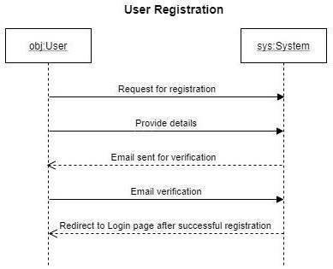

Smart Steel & Bricks **28**

*Chapter 3* *System Analysis*

**3.3.2** **Login System Sequence Diagrams**

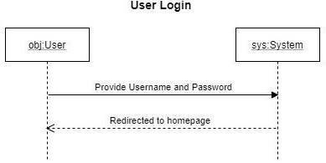

**3.3.3** **Edit Profile System Sequence Diagrams**

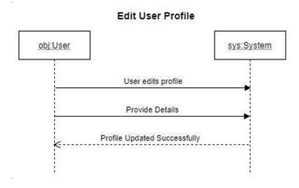

Smart Steel & Bricks **29**

*Chapter 3* *System Analysis*

**3.3.3** **Delete System Sequence Diagrams**

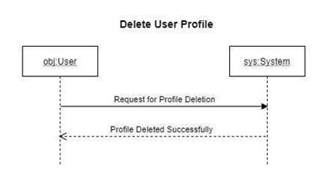

**3.3.4** **Browse Product System Sequence Diagrams**

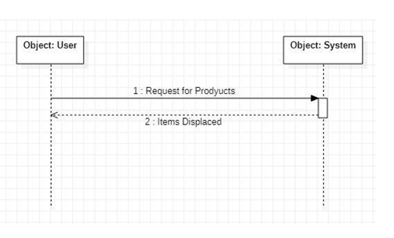

Smart Steel & Bricks **30**

*Chapter 3* *System Analysis*

**3.3.5** **Update Information Sequence Diagrams**

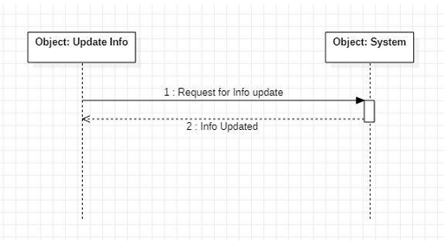

**3.3.6** **Checkout System Sequence Diagrams**

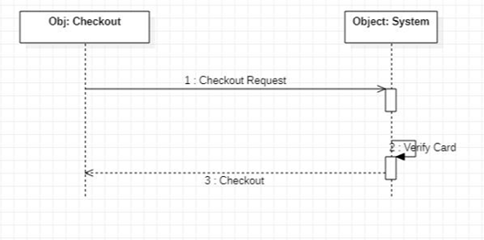

Smart Steel & Bricks **31**

*Chapter 3* *System Analysis*

**3.3.7** **Add to Cart Sequence Diagrams**

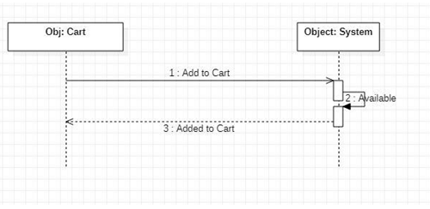

**3.3.8** **Search Product Sequence Diagrams**

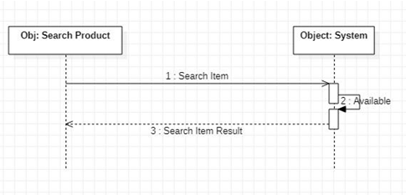

Smart Steel & Bricks **32**

*Chapter 3* *System Analysis*

**3.3.9** **Track Order Sequence Diagrams**

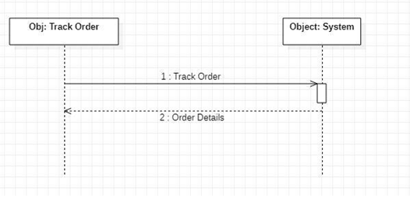

**3.3.10** **Update Product Sequence Diagrams**

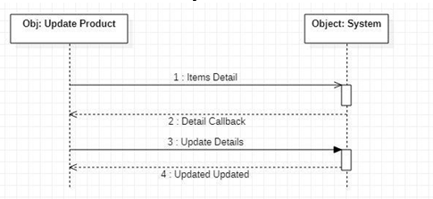

Smart Steel & Bricks **33**

*Chapter 3* *System Analysis*

**3.3.11** **Ship Product Sequence Diagrams**

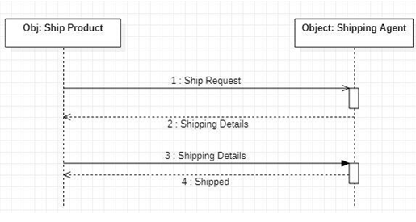

**3.3.12**  **Verify Payment Product Sequence Diagrams**

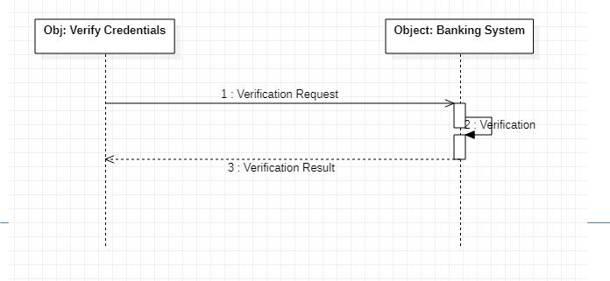

Smart Steel & Bricks **34**

\

**Chapter 4**

**System Design**

*Chapter 4* *System Design*

1. System Design

Here we define the components, modules, interfaces, and data for Smart Steel & Bricks to assure specified requirements in system analysis are satisfied. The following details the procedure of creating or altering systems, along with the processes, practices, models, and methodologies used to develop this web application.

4.1 Architectural Diagram

Here a brief set of concepts, that are part of an architecture, including their elements and components. Smart Steel & Bricks takes full advantage of the Mern Stack which takes the “batteries included” approach and has all the generic functionalities built into the technology itself which encourages rapid development and clean, pragmatic design. It takes care of much of the hassle of web development, so focus can be diverted on writing the app without needing to reinvent the wheel.

**Figure 4-1** Architecture Diagram

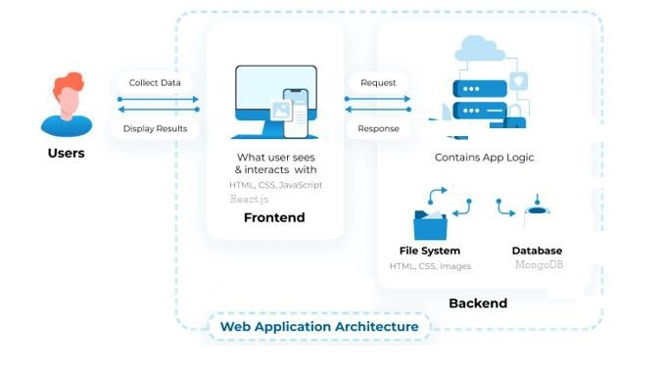

Smart Steel & Bricks **36**

*Chapter 4* *System Design*

4.2 Data Flow Diagram

An illustration of how data is processed by the Smart Steel & Bricks web app in terms of inputs and outputs. Its focus is on the flow of information, such as where data comes from and where it goes and depicts the behavior of a system. The following data flow diagram can be used to analyze the system.

**Figure 4-2** Data Flow Diagram

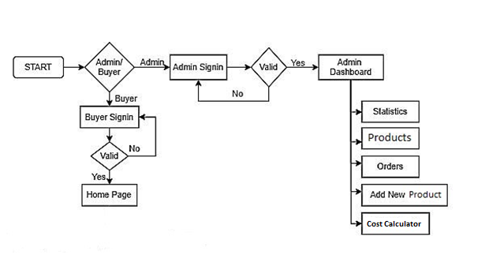

Smart Steel & Bricks **37**

*Chapter 4* *System Design*

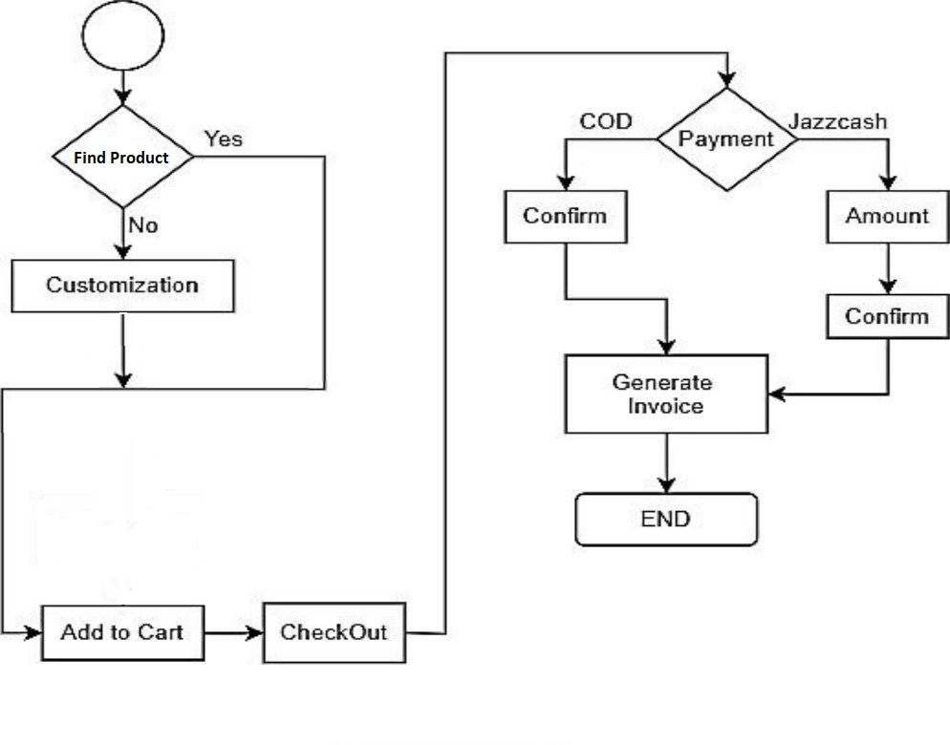

Data Flow Diagram (Cont.)

Smart Steel & Bricks **38**

*Chapter 4* *System Design*

4.3 Class Diagram

**Figure 4-3** Class Diagram

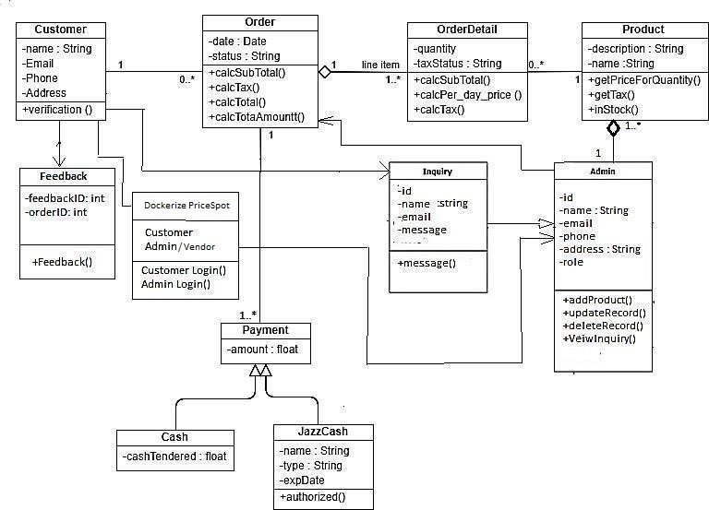

Smart Steel & Bricks **39**

*Chapter 4* *System Design*

4.4 ERD/Database Schema

It is used for general conceptual modeling ERD of the application, and for detailed modeling, translating the models into programming code.This can also be used for data modeling. The following is the ERD for the models implemented in the web app that illustrates how “entities” such as people, objects or concepts relate to each other within a system.

**Figure 4-4** ERD

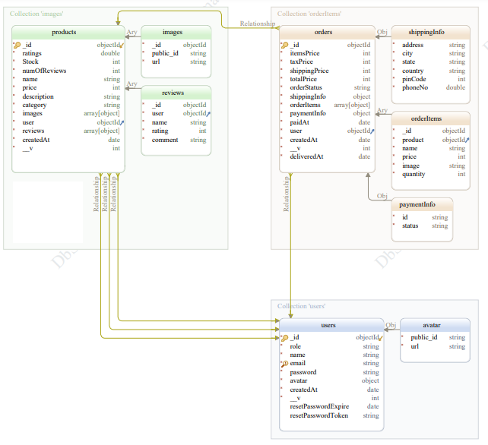

Smart Steel & Bricks **40**

*Chapter 4* *System Design*

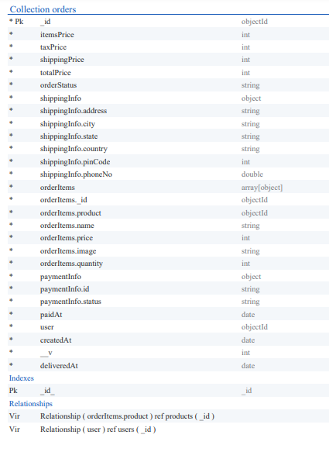

Smart Steel & Bricks **41**

*Chapter 4* *System Design*

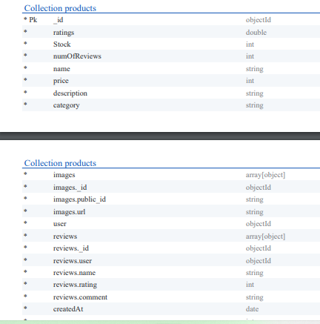

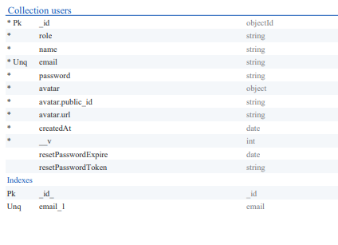

Smart Steel & Bricks **42**

**Chapter 5**

**Implementation**

*Chapter 5* *Implementation*

1. Implementation

This is a core part of any app’s lifecycle. The phase describes the tech stack used to implement the project. This web app was build using the MERN full stack framework which is widely used python framework. It is based on the Model View Template architecture.

**Figure 0-1** React Architecture

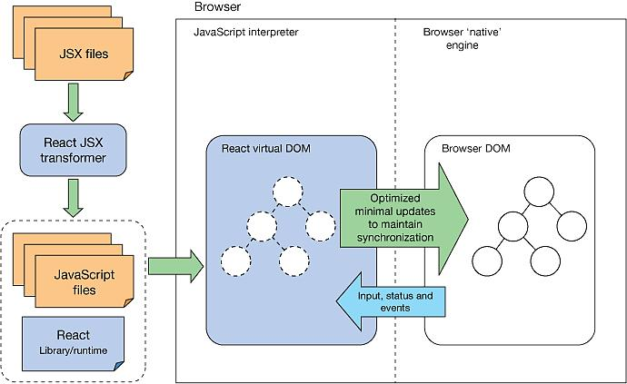

5.1 Frontend

The front end was implemented using REACT.JS which provides the ability to make responsive and Single page web apps, where different views are called to fetch and display specific data without the need for a full page reload, hence increasing performance. In addition to that, html, bootstrap and JavaScript, were used to style and make the web app responsive on all devices.

Smart Steel & Bricks **44**

*Chapter 5* *Implementation*

5.2 Backend

Node.js is a back-end JavaScript Runtime Environment that runs on a JavaScript Engine (i.e V8-Engine) and executes JavaScript code outside a web-Browser, which was designed to build scalable network applications. Node.js lets developers use JavaScript to write command line tools and for Server-Side Scripting—running scripts server-side to produce dynamic webpage content before the page is sent to the user's web browser. Consequently, Node.js represents a "JavaScript everywhere" paradigm, unifying web application development around a single programming language, rather than different languages for server-side and client-side scripts. Node.js has an event-driven architecture capable of asynchronous I/O. These design choices aim to optimize throughput and scalability in web applications with many input/output operations, as well as for real-time applications

5.3 Database

MongoDB database is used to store details of Buyers, and admins and store staff if required, record of Leasing and buying products. It also keeps the record of stored items. The MongoDB Database is a NoSQL database that lets you store and sync data between your users in real-time. It is just a big JSON object where you can store whatever you want inside. There is a schema for the database, but no tables, no columns, it is just a combination of documents and collections.

First, we establish a connection to the MongoDB database by fetching credentials in a link

form because it does not allow to connect without having credentials. As there is no SQL, queries are also not used. Therefore, we have linked with mongodb Admin, buyer, and used real-time database to store Product details and sales.

* User Record (Buyer, Admin).
* Product Record (Price, Quantity, Category).
* Sales Record (Total Sales, Buyer’s sales).

Smart Steel & Bricks **45**

*Chapter 5* *Implementation*

***Figure 0-2*** *MongoDB Basic Architecture*

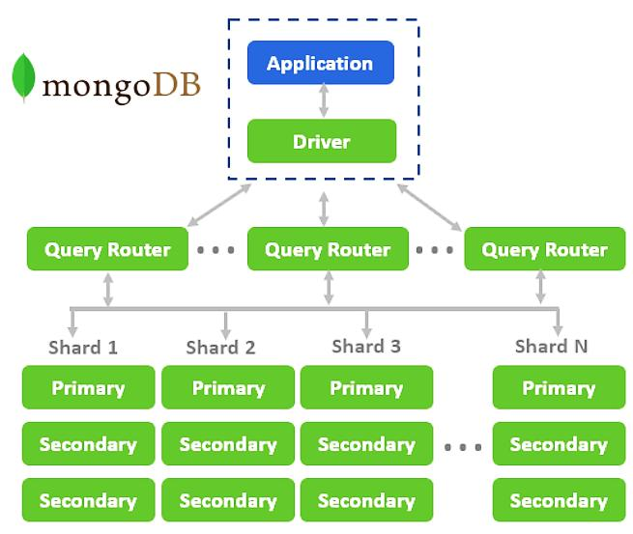

Smart Steel & Bricks **46**

*Chapter 5* *Implementation*

5.4 Development Tools

The web app uses variety of different technologies to make a secure and robust full stack web application. Following tools were used to develop this web application

|  |  |  |
| --- | --- | --- |
|  | **Table 0-1** Development Tools | |
|  |  |  |
| OS |  | Windows 10 (64-bit) |
|  |  |  |
| IDE |  | Microsoft Visual Studio Code |
|  |  |  |
| Database visualization |  | Tableau |
|  |  |  |
| API Testing |  | Postman API |
|  |  |  |
|  |  | HTML |
|  |  | CSS |
|  |  | Bootstrap |
| Languages |  | React.js |
|  |  | Express.js |
|  |  | Node.js |
|  |  | JavaScript |
|  |  |  |
| Documentation |  | Microsoft Word 2016 |
|  |  |  |
| Browser |  | Google Chrome Browser |
|  |  |  |

Smart Steel & Bricks **47**

*Chapter 5* *Implementation*

5.5 System UI

Below is a Brief list of the system UI, attachments include the screenshots of the main modules

5.5.1 Login / Register

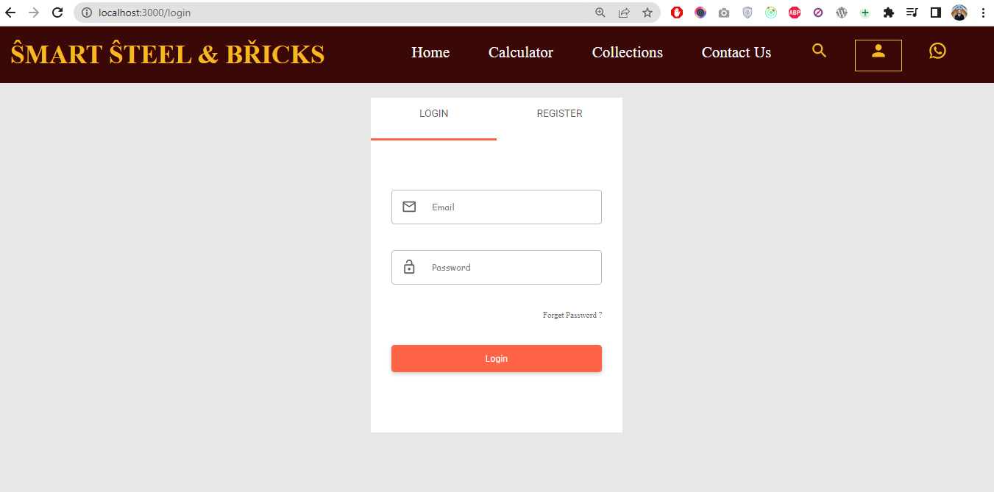

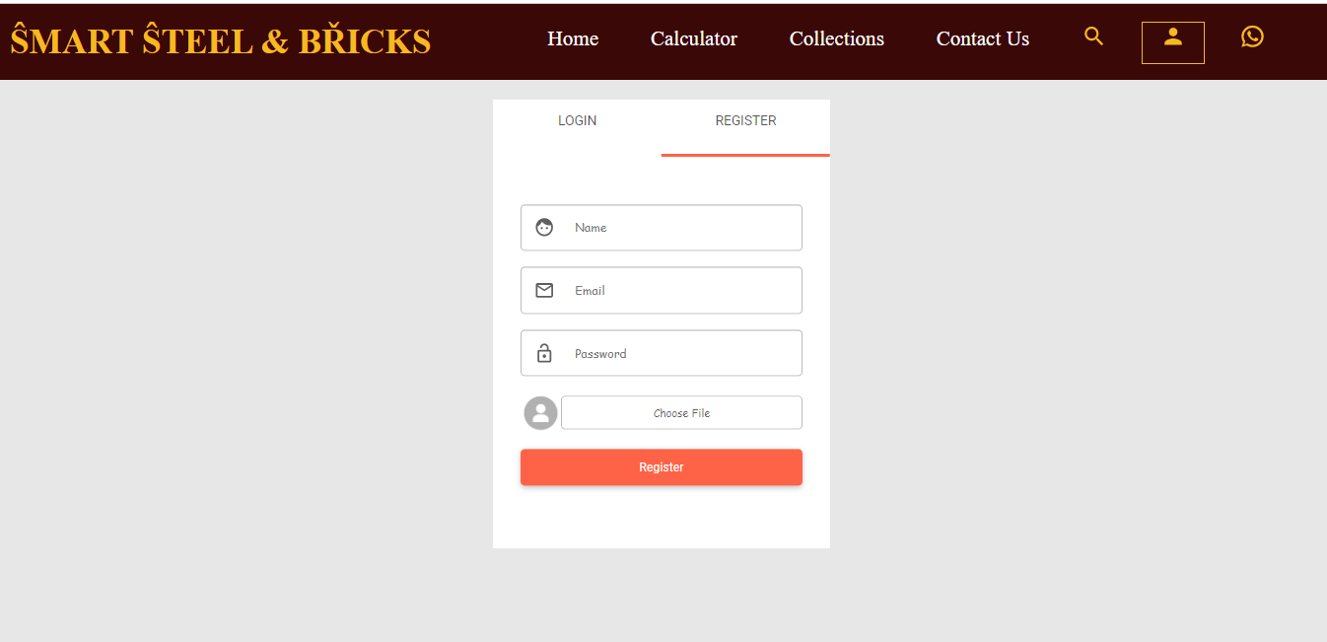

Smart Steel & Bricks **48**

*Chapter 5* *Implementation*

5.5.2 Profile Section

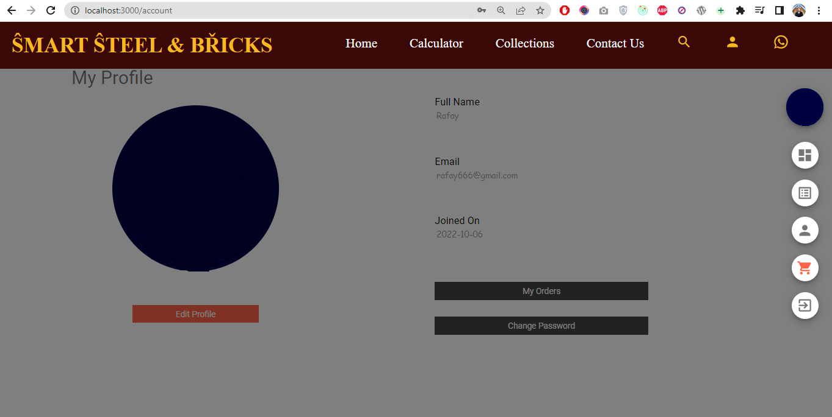

Smart Steel & Bricks **49**

*Chapter 5* *Implementation*

5.5.3 Home Page

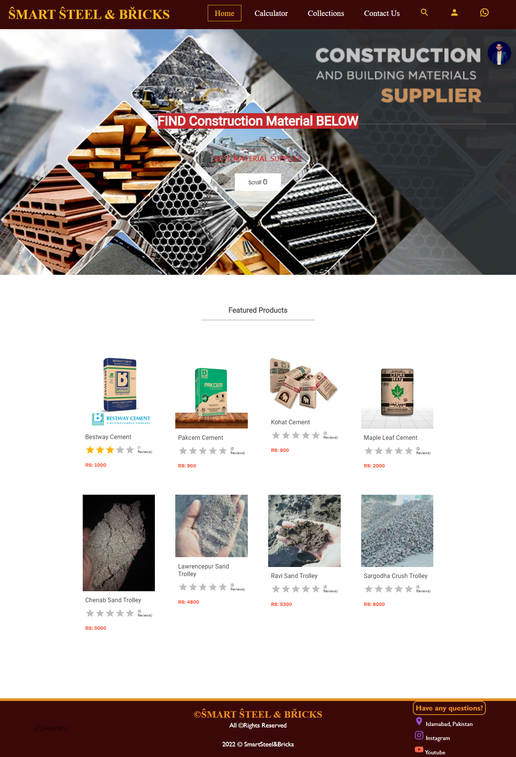

Smart Steel & Bricks **50**

*Chapter 5* *Implementation*

5.5.4 Estimator Calculator Page

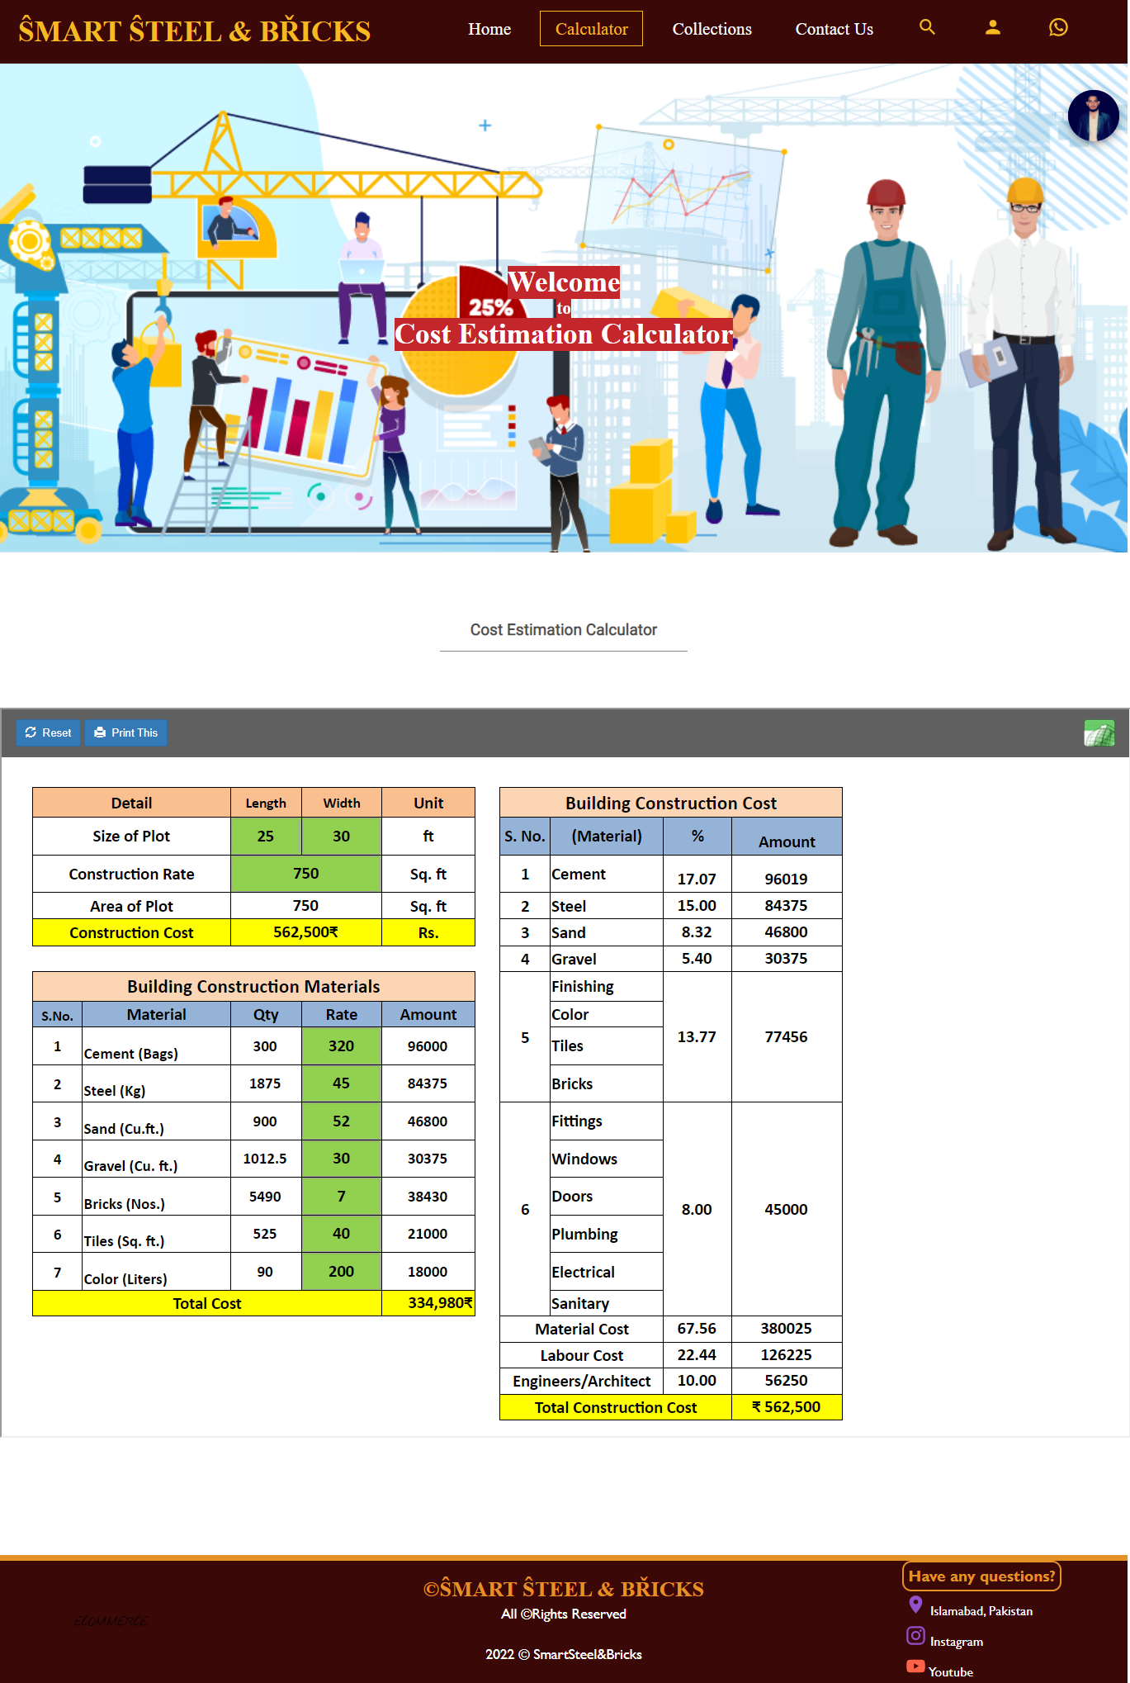

Smart Steel & Bricks **51**

*Chapter 5* *Implementation*

5.5.5 Print Estimator Page

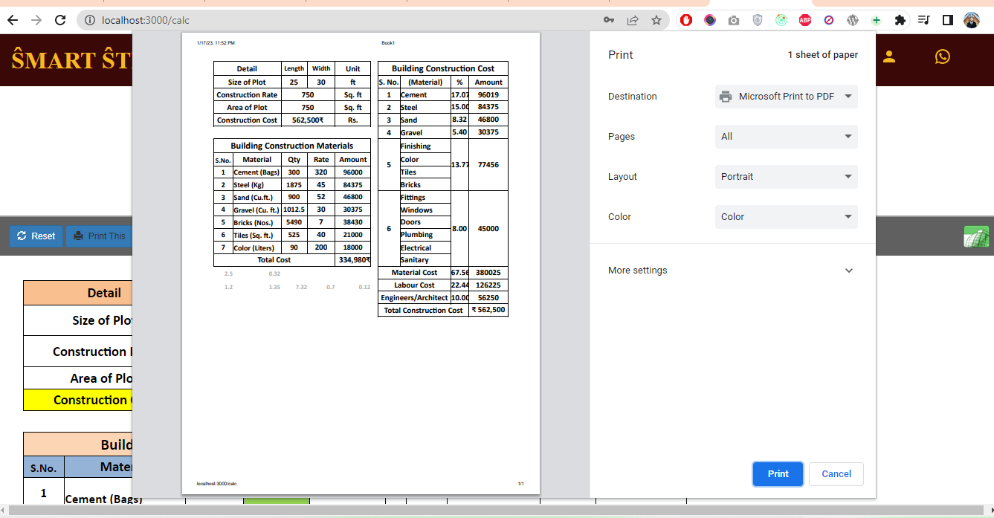

Smart Steel & Bricks **52**

*Chapter 5* *Implementation*

5.5.6 Search Product Page

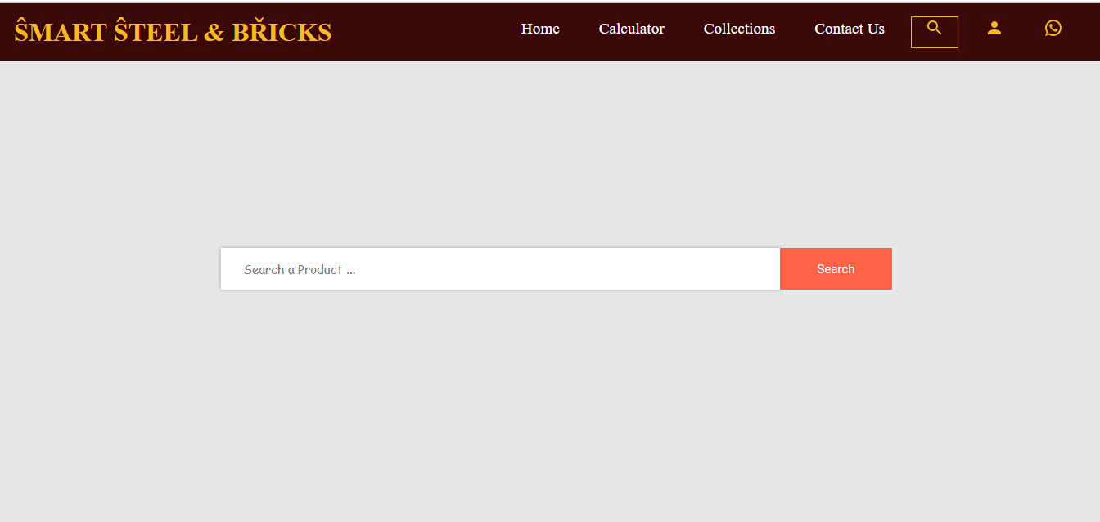

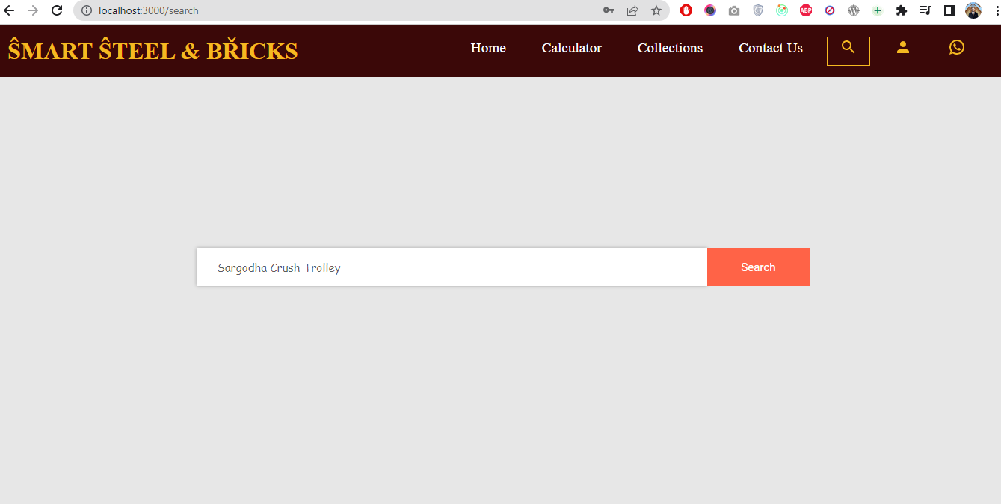

Smart Steel & Bricks **53**

*Chapter 5* *Implementation*

5.5.7 Product Collection

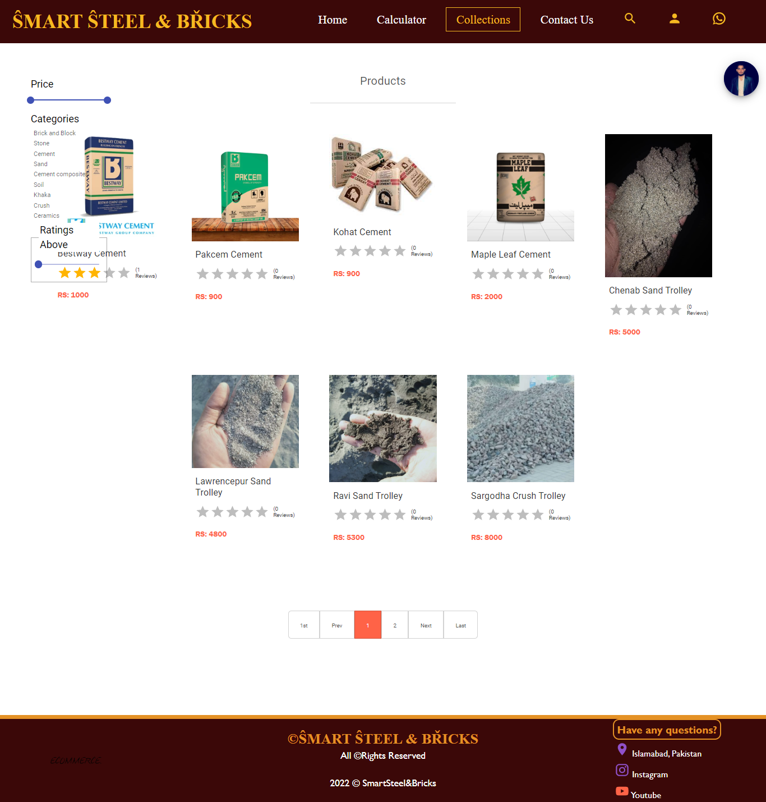

Smart Steel & Bricks **54**

*Chapter 5* *Implementation*

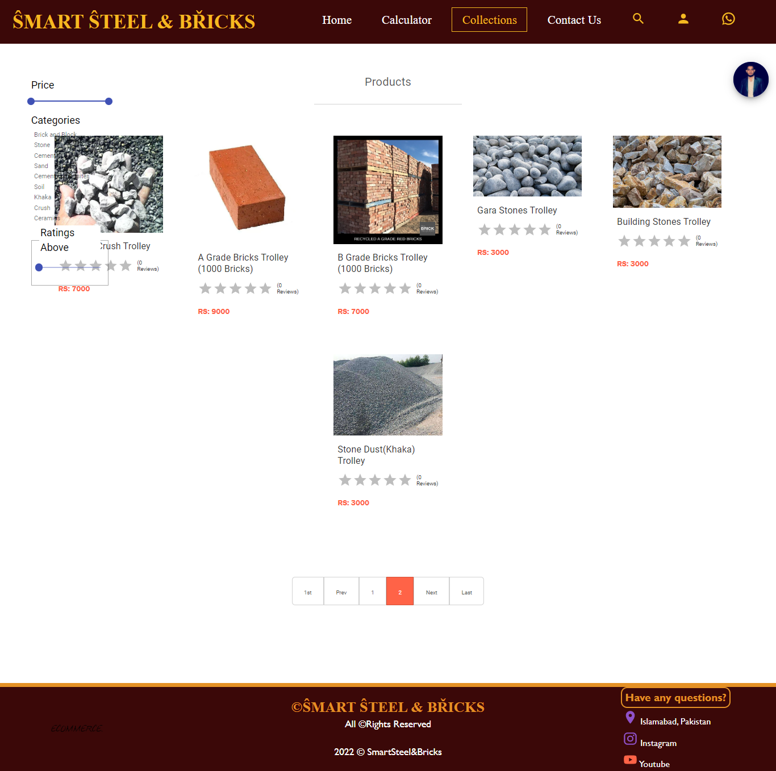

Smart Steel & Bricks **55**

*Chapter 5* *Implementation*

5.5.8 Contact us Page

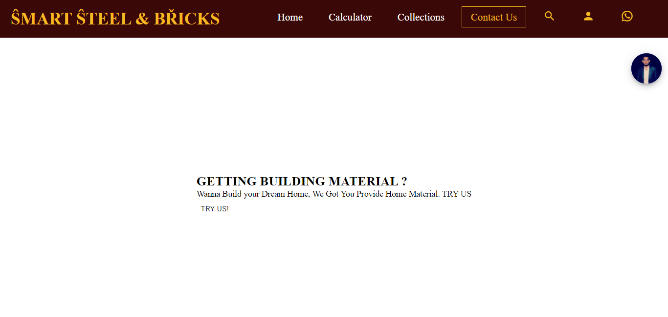

5.5.9 Product Filter

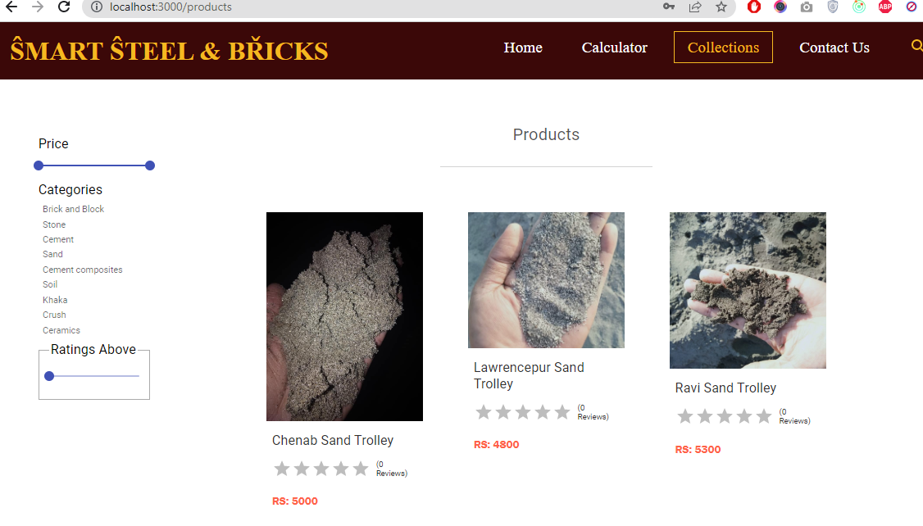

Smart Steel & Bricks **56**

*Chapter 5* *Implementation*

5.5.10 Product Details

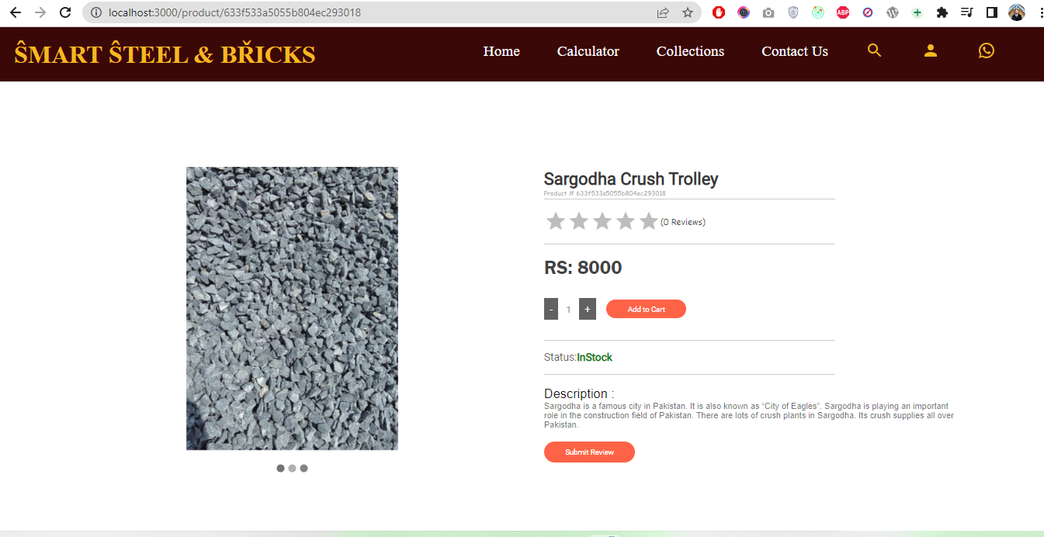

Smart Steel & Bricks **57**

*Chapter 5* *Implementation*

5.5.11 Admin Dashboard

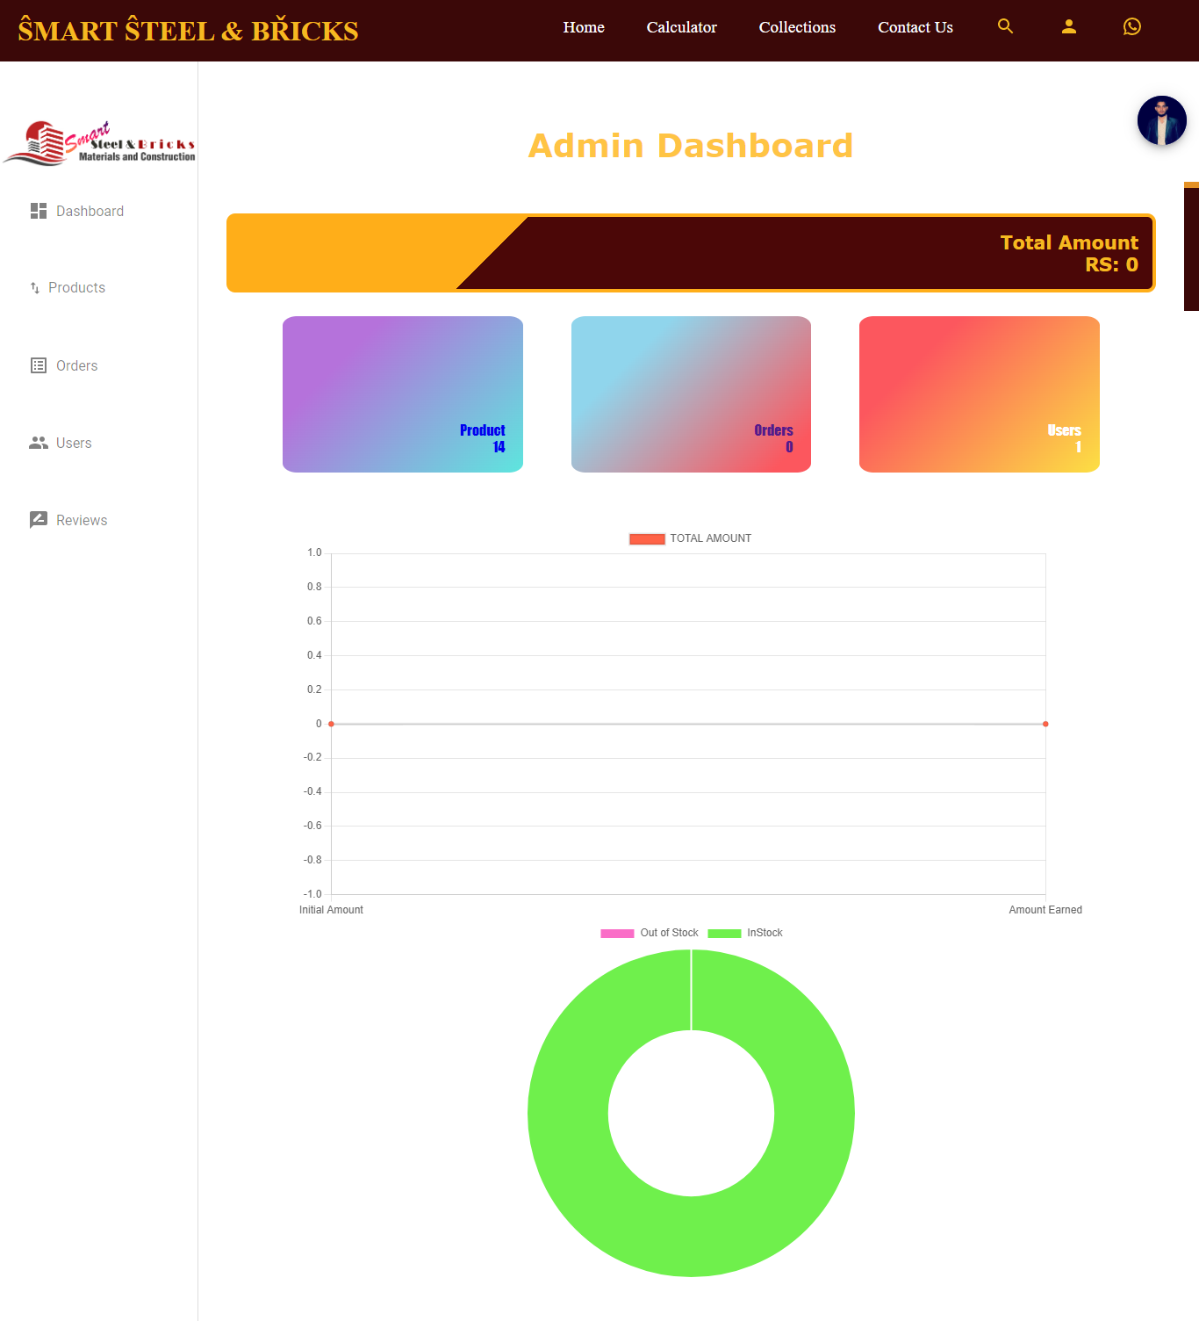

Smart Steel & Bricks **58**

*Chapter 5* *Implementation*

5.5.12 Create new product

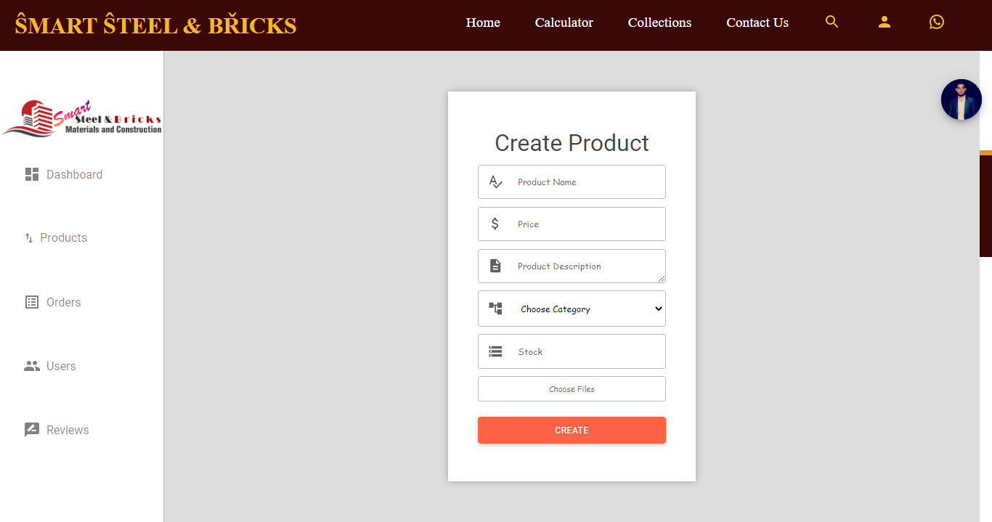

Smart Steel & Bricks **59**

*Chapter 5* *Implementation*

5.5.13 Track All Orders

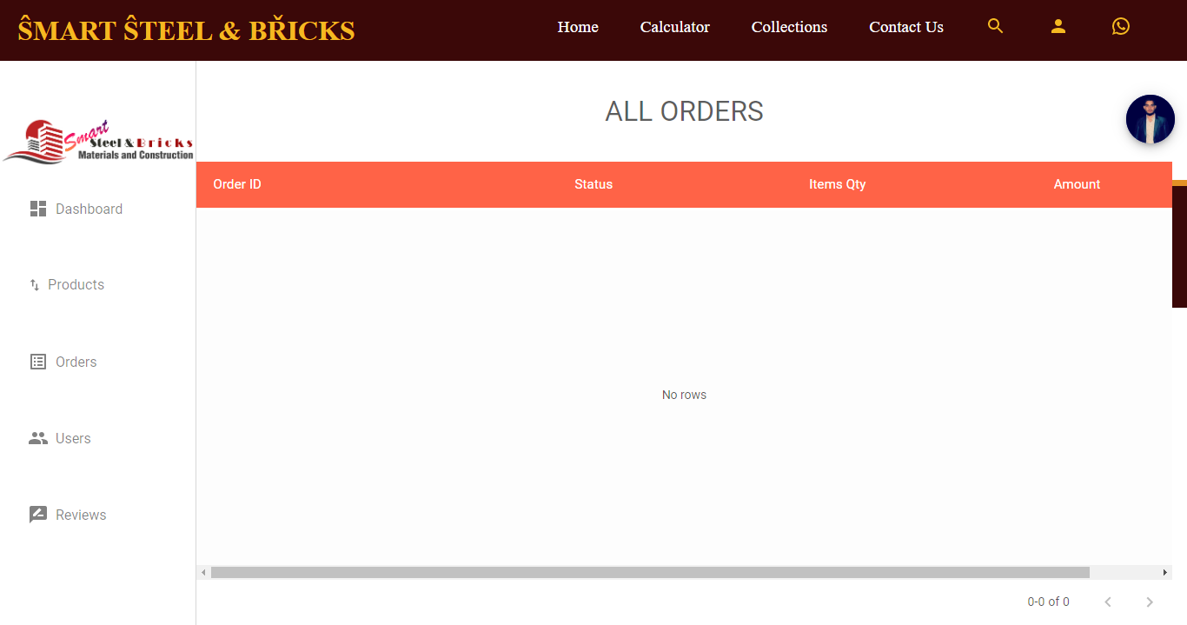

5.5.13 Update User Role

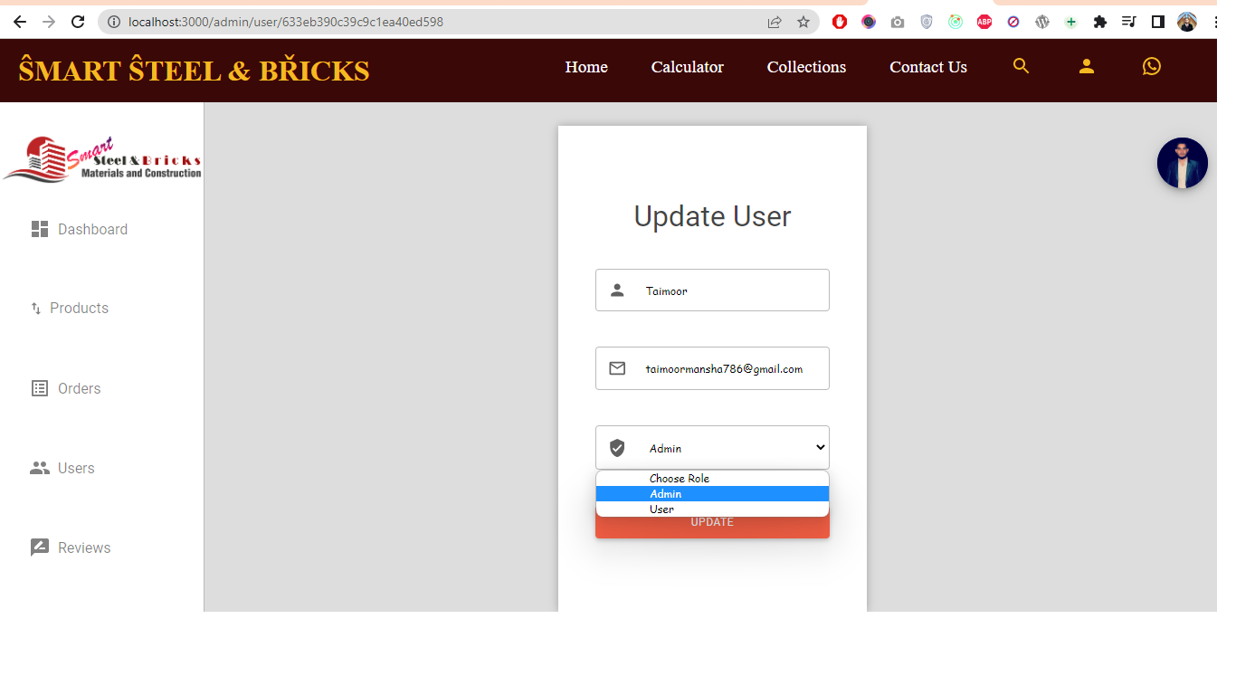

Smart Steel & Bricks 60

*Chapter 5* *Implementation*

5.5.14 See All Reviews

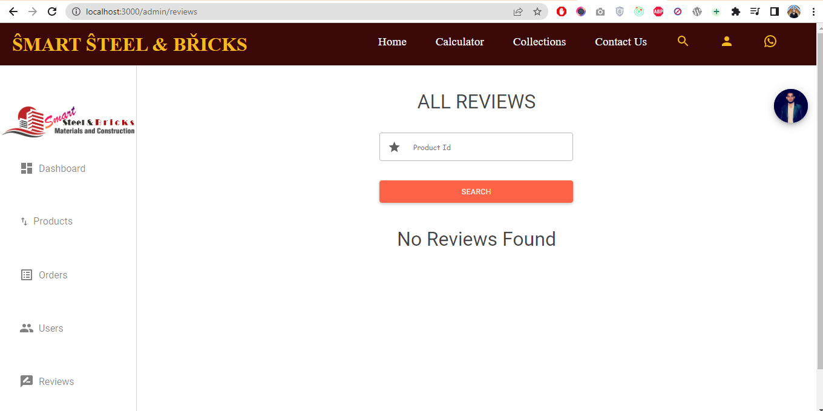

Smart Steel & Bricks **61**

*Chapter 5* *Implementation*

5.5.15 Add to Cart

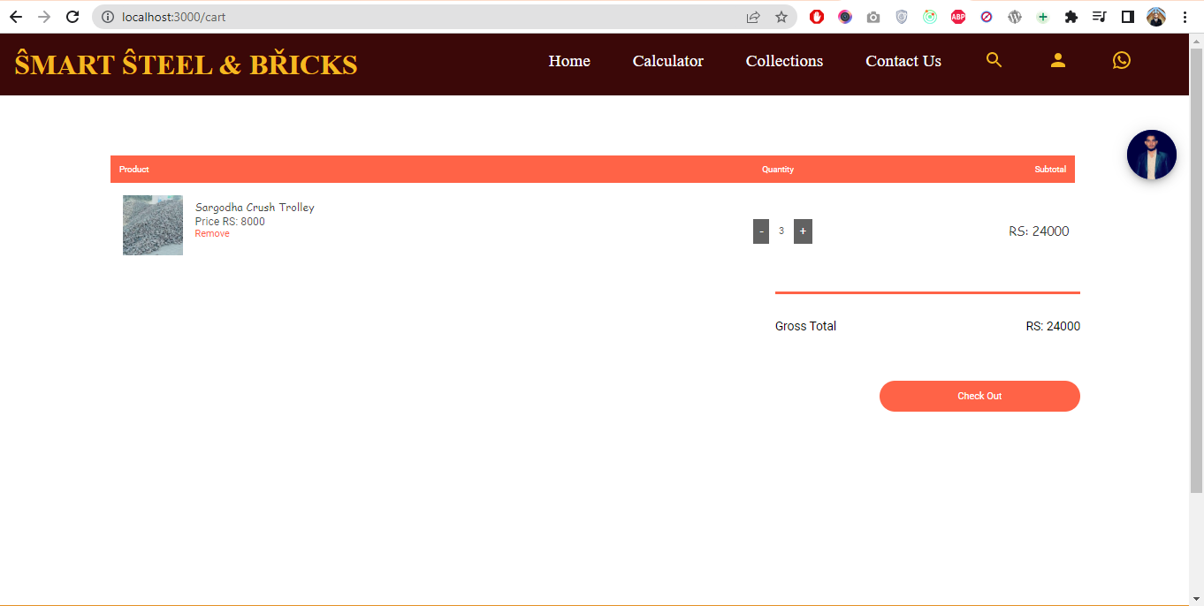

Smart Steel & Bricks **62**

*Chapter 5* *Implementation*

5.5.16 Shipping Information

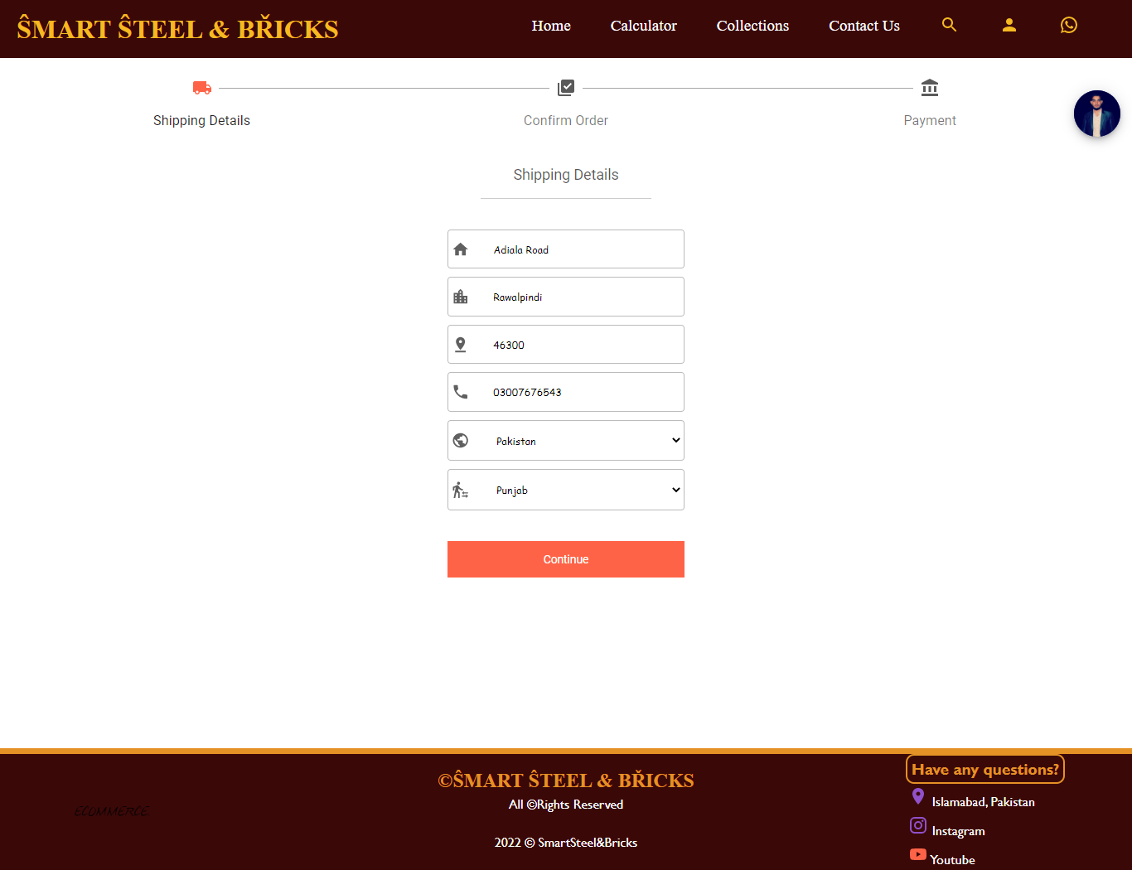

Smart Steel & Bricks **63**

*Chapter 5* *Implementation*

5.5.16 Shipping Information (continue)

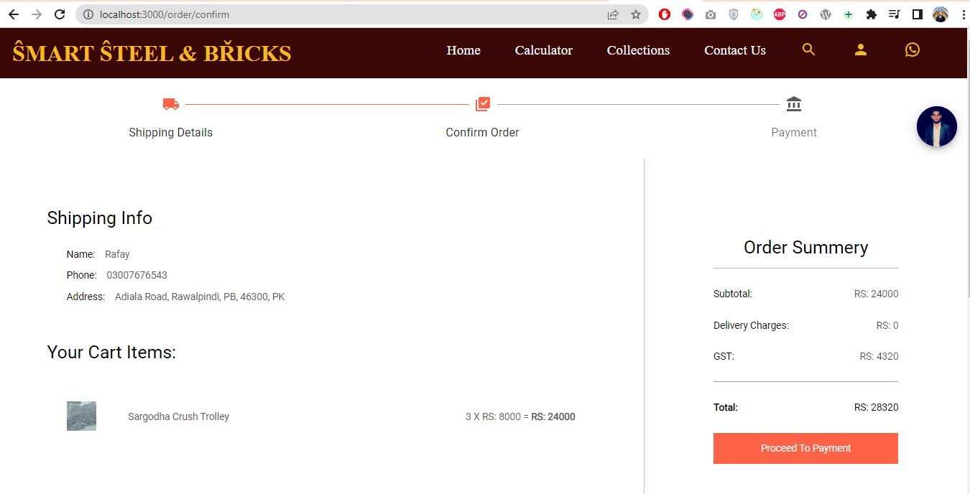

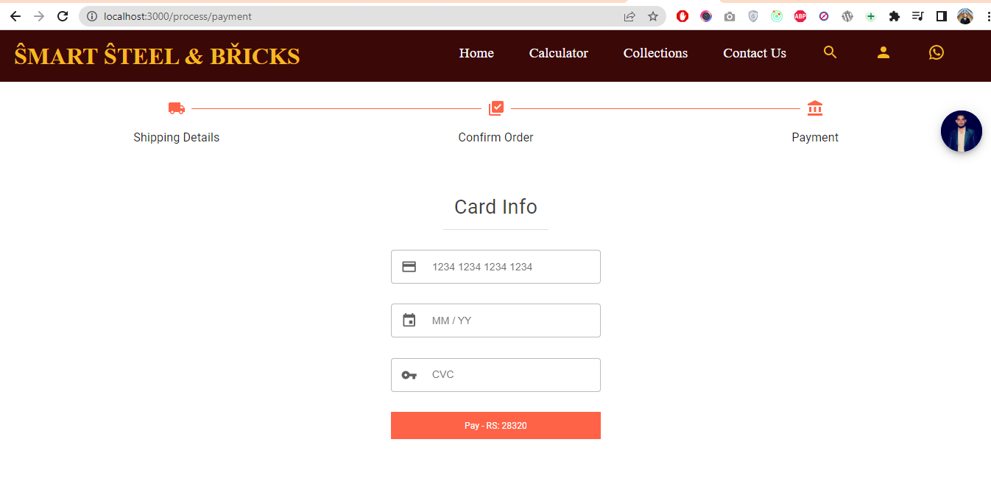

Smart Steel & Bricks **64**

**Chapter 6**

**System Testing**

*Chapter 6* *System Testing*

6 System Testing

In this phase the quality of various components of the web application is tested, evaluated and verified and ensured that everything is working as intended and the phase focuses on the functionality of the application and offers fulfillment to an engineer and provides quality assurance for the whole web application. In Dockerize PriceSpot to accomplish this variety of tests are used including performance, usability and functional tests.

6.1 Test Cases

In this application every kind of user input and the intended output has been tested. The testing framework used was Mern Stack built in test framework which helps with both unit and integration tests. System tests conjointly aid within the detection of faults, gaps, or missing necessities in actual software system compared to user and system specifications. Testing takes place at the section level of the event life cycle or at the module level of the program code. Testing contains validation and verification. First, we tend to tested signup details of client by corroboratory it through a signaling. OTP are going to be sent to client on its provided range to verify his details. User panel is additionally tested either orders area unit placement is practical or not.

The plan includes an understanding of the level of risk.

We test our system in different environment such as

We have tested location where to deliver the products.

We have tested products are updating in database

We have tested system when internet connection is down.

We have tested cart and number of items in stock.

We have tested payment-gate-way.

Smart Steel & Bricks **66**

*Chapter 6* *Testing*

The most essential test cases are listed below:

**Test Cases**

**Table 6.1: Test Case # 01 Register and Login**



|  |  |  |  |  |  |  |
| --- | --- | --- | --- | --- | --- | --- |
|  | **Project Name** | **Smart Steel and Bricks** | **Test Designed by** |  |  | |
|  |  |  |  |  | | |
|  | **Test Case** | Register and Login | Test Designed | 16-12-2022 | |  |
|  | **Name** |  | date |  |  |  |
|  | **Module** | Software | Test Executed by |  | | |
|  |  |  |  |  | | |
|  |  |  | Test Execution | 16-12-2022 | |  |
|  |  |  | date |  |  |  |
|  |  |  |  |  |  |  |
|  | **Pre-** | Laptop |  |  |  |  |
|  | **Condition** |  |  |  |  |  |
|  | **Dependency** | None |  |  |  |  |
|  |  |  |  |  |  |  |
|  | **Test Priority** | High |  |  |  |  |
|  |  |  |  |  |  | |
|  | **Test Case # 1** | Test Summary | Test Steps |  | Test Data | |
|  |  |  |  | |  | |
|  |  | Seller/Buyer must be | Easy to register and after register | | Validate | |
|  |  | registered | Login |  |  |  |

**Table 6.2: Test Case # 02 Manage profiles**



|  |  |  |  |  |  |  |  |
| --- | --- | --- | --- | --- | --- | --- | --- |
|  | **Project Name** | **Smart Steel and Bricks** |  | **Test Designed by** |  |  | |
|  |  |  |  |  |  |  | |
|  | **Test Case** | Manage profiles | by | Test Designed date 17-12-2022 | | | |
|  | **Name** | Buyers and Sellers |  |  |  |  |  |
|  | **Module** | Software |  | Test Executed by |  |  | |
|  |  |  |  |  |  | | |
|  |  |  |  | Test Execution date |  | 17-12-2022 |  |
|  |  |  |  |  |  |  |  |
|  |  |  |  |  |  |  |  |
|  | **Pre-** | Laptop |  |  |  |  |  |
|  | **Condition** |  |  |  |  |  |  |
|  | **Dependency** | None |  |  |  |  |  |
|  |  |  |  |  |  |  |  |
|  | **Test Priority** | High |  |  |  |  |  |
|  |  |  |  |  |  |  | |
|  | **Test Case # 2** | Test Summary |  | Test Steps |  | Test Data | |
|  |  |  |  |  | | | |
|  |  | Seller/Buyer can |  | Easy to update the details of user Validate and | | | |
|  |  | manage their profiles |  | agent |  |  |  |

Smart Steel & Bricks **67**

*Chapter 6* *Testing*



|  |  |  |  |  |
| --- | --- | --- | --- | --- |
| **Table 6.3: Test Case # 03 Clicks, Impression** | | | **s, Views** |  |
| **Project Name** | **Smart Steel and Bricks** | | **Test Designed by** |  |
|  |  |  |  |  |
| **Test Case** | Clicks, Impressions, | | Test Designed date | 18-12-2022 |
| **Name** | Views |  |  |  |
| **Module** | Software | | Test Executed by |  |
|  |  |  |  |  |
|  |  |  | Test Execution | 18-12-2022 |
|  |  |  | date |  |
|  |  |  |  |  |
| **Pre-** | Laptop |  |  |  |
| **Condition** |  |  |  |  |
| **Dependency** | None |  |  |  |
|  |  |  |  |  |
| **Test Priority** | High |  |  |  |
|  |  | |  |  |
| **Test Case # 3** | Test Summary | | Test Steps | Test Data |
|  |  |  |  | |
|  | Seller | can check | Clicks, Impressions and Views will | |
|  | his | product’s | show in Seller Dashboard |  |
|  | clicks, |  |  |  |

impressions, and

views



**Table 6.4: Test Case # 04 Orders Records**



|  |  |  |  |  |  |  |
| --- | --- | --- | --- | --- | --- | --- |
|  |  | **Project Name** | **Smart Steel and Bricks** | **Test Designed by** | **Faiez,** | |
|  |  |  |  |  |  | |
|  |  | **Test Case** | Check Order | Test Designed date | 20-12-2022 |  |
|  |  | **Name** | Records |  |  |  |
|  |  | **Module** | Software | Test Executed by |  | |
|  |  |  |  |  |  | |
|  |  |  |  |  |  |  |



Test Execution date 20-12-2022



|  |  |  |  |  |  |  |
| --- | --- | --- | --- | --- | --- | --- |
|  | **Pre-** | Laptop |  |  |  |  |
|  | **Condition** |  |  |  |  |  |
|  | **Dependency** | None |  |  |  |  |
|  |  |  |  |  |  |  |
|  | **Test Priority** | High |  |  |  |  |
|  |  |  | |  |  |  |
|  | **Test Case # 4** | Test Summary | |  | Test Steps | Test Data |
|  |  |  |  |  |  |  |
|  |  | Orders | records | and | Click on Orders then active order to | Validate |
|  |  | information related to | | | check order history and records |  |
|  |  | orders | showing | in | about currently active orders. |  |
|  |  | dashboard | |  |  |  |

Smart Steel & Bricks **68**

*Chapter 6* *Testing*



**Table 6.5: Test Case # 05 Query Products**



|  |  |  |  |  |  |  |
| --- | --- | --- | --- | --- | --- | --- |
|  | **Project Name** | **Smart Steel and Bricks** | **Test Designed by** |  | **,** | |
|  |  |  |  |  | | |
|  | **Test Case** | Query Products | Test Designed | 22-12-2022 | |  |
|  | **Name** |  | date |  |  |  |
|  | **Module** | Software | Test Executed by |  | | |
|  |  |  |  |  | | |
|  |  |  |  |  | |  |
|  |  |  | Test Execution date | 22-12-2022 | |  |
|  |  |  |  |  |  |  |
|  |  |  |  |  |  |  |
|  | **Pre-** | Laptop |  |  |  |  |
|  | **Condition** |  |  |  |  |  |
|  | **Dependency** | None |  |  |  |  |
|  |  |  |  |  |  |  |
|  | **Test Priority** | High |  |  |  |  |
|  |  |  |  |  |  |  |
|  | **Test Case # 5** | Test Summary | Test Steps |  | Test | |
|  |  |  |  |  | Data |  |
|  |  | When buyer try to | Buyer have to click on search box in | | Validate | |
|  |  | search some item | In his dashboard to check his | |  |  |
|  |  | in search box. | desired product or model | |  |  |
|  |  |  | of product. |  |  |  |

**Table 6.6: Test Case # 06 Payment Gateway**



|  |  |  |  |  |
| --- | --- | --- | --- | --- |
| **Project Name** | **Smart Steel and Bricks** |  | **Test Designed by** |  |
|  |  |  |  |  |
| **Test Case** | Payment |  | Test Designed date | 23-12-2022 |
| **Name** | Gateway |  |  |  |
| **Module** | Software |  | Test Executed by |  |
|  |  |  |  |  |
|  |  |  | Test Execution date | 23-12-2022 |
|  |  |  |  |  |
|  |  |  |  |  |
| **Pre-** | Laptop |  |  |  |
| **Condition** |  |  |  |  |
| **Dependency** | None |  |  |  |
|  |  |  |  |  |
| **Test Priority** | High |  |  |  |
|  |  |  | |  |
| **Test Case # 6** | Test Summary | Test Steps | | Test |
|  |  |  |  | Data |
|  | There is an option of | If any seller demands for some Validate | | |
|  | advance payment | advance payment buyer shave to make | | |
|  | which buyer must | Through Jazz Cash. | |  |
|  | make optionally. |  |  |  |

Smart Steel & Bricks **69**

*Chapter 6* *Testing*

6.2 Performance Evaluation

For high speed responsiveness a modern lightweight JavaScript framework called HTMX is used which similar to react renders different components in a single view on a single page, hence decreasing load times and increasing performance

6.3 Testing Summary

In testing we find many minor negligence may lead to faulty working. We faced location issues some places were not accurate in start but later optimized. While updating the record in database some data was not stored which was resolved after testing out software on different data.

Smart Steel & Bricks **70**

**Chapter 7**

**Conclusion**

*Chapter 7* *Conclusion*

7 Conclusion

This is a web application Product on the web, it works with individuals. Our task is to foster web application in which client can undoubtedly get any Product web-based in extremely less time. Make an effort not to need to go to the market to visit every single shop, as of now you can visit for all intents and purposes by checking things i.e. Products on the web. Individuals who can't deal with the expense of Expensive Products will get. This application ensures straightforward Policy for the clients and furthermore delivers and prints the receipt for each productive trade Component of extraordinary offers will be added to extend bargain. Client can likewise give feedback and bidding about the Product and administration. Our web application will show total bill with conveyance charges so client can pay. We can ensure about quality and amount both while perhaps bad then client can drop their request. Web based shopping can be scary in our advanced period of Internet misrepresentation. In any case, it doesn't need to be like that. we offers you a protected and safe shopping environment for all clients. We use trusted payment processing systems There will be choice for online installment and correspondence in our web application. From the beginning to the end of your shopping experience with us, we are devoted to satisfying you.

7.1 Achievements and Improvements

This is successfully deployed methodology and users can visit and test out the Project modules.

In the growing overall economy, web business and e-business have in a matter of seconds transformed into a fundamental piece of business method and a strong engine for monetary headway. The use of information and correspondence advancement in the workplace has changed associations both inside associations and among associations and individuals. We fail to remember that there are those on the world who don't have even the advantage of agreeable. Each user ought to require a product for their uncommon days. There are no similar stages existing in Pakistan. Similarly, structures can

Smart Steel & Bricks **72**

*Chapter 6* *Testing*

be found on web all around, but they have very limited Policies and forgotten to make their place in market. Smart Steel & Bricks has a particularly basic tremendous augmentation in giving effortlessness to people. Worldwide ecommerce Platforms have incredibly serious product trades when stood out from the Smart Steel & Bricks.

As for improvements, no app is perfect and there is always room to grow. It is the case with Smart Steel & Bricks. The room for more functionality is endless and with the tech stack used for this app the potential for scalability is massive.

7.2 Future Enhancements

Staying with ever changing web development landscape, the current plan is to turn the web into a progressive web app and introduce a mobile application for further assistance of users and making the web app 100% automated.

Smart Steel & Bricks **73**

**References**

*References*

**Documentation**

1. <https://www.allborrow.com/>
2. <https://www.hautevault.com/>
3. <https://www.redcarpetrocks.com/>
4. <https://online.visual-paradigm.com/>
5. <https://htmx.org/>
6. https://hyperscript.org/docs/

**General Queries**

1. <https://stackoverflow.com/>
2. <https://medium.com/>
3. https://www.geeksforgeeks.org/
4. <https://www.w3school.com/>
5. <https://youtube.com/>

Smart Steel & Bricks **75**